Year 3 – Term 4
I know the division facts for the 4 times table.
By the end of this half term, children should know the following facts. The aim is for them to recall these facts instantly.
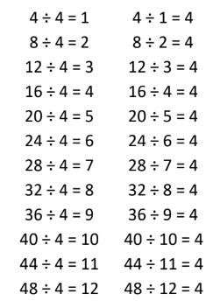

They should be able to answer these questions in any order, including missing number questions e.g. ⃝ ÷ 4 = 7.
Top Tips
The secret to success is practising little and often. Use time wisely. Can you practise these KIRFs while walking to school or during a car journey? You don’t need to practise them all at once: perhaps you could have a fact family of the day.
- Can you link these to the 4 times table?
- Make links to dividing by 2 – halve and then halve again.

