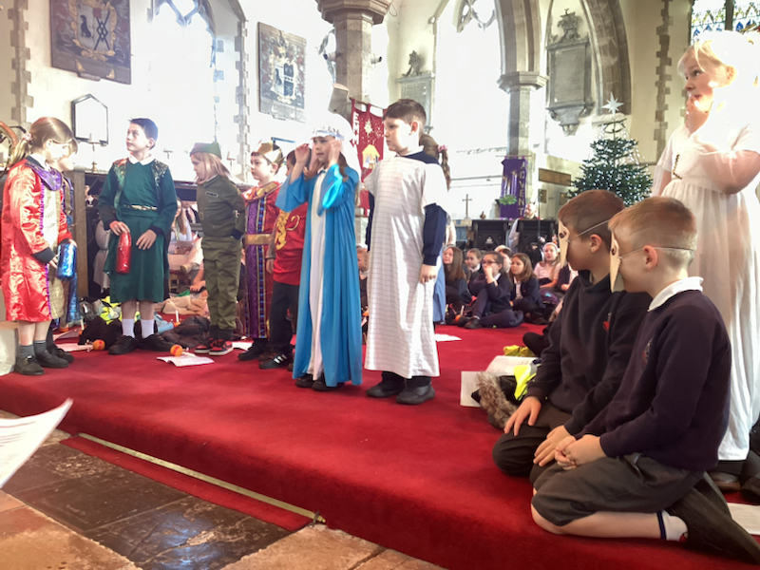
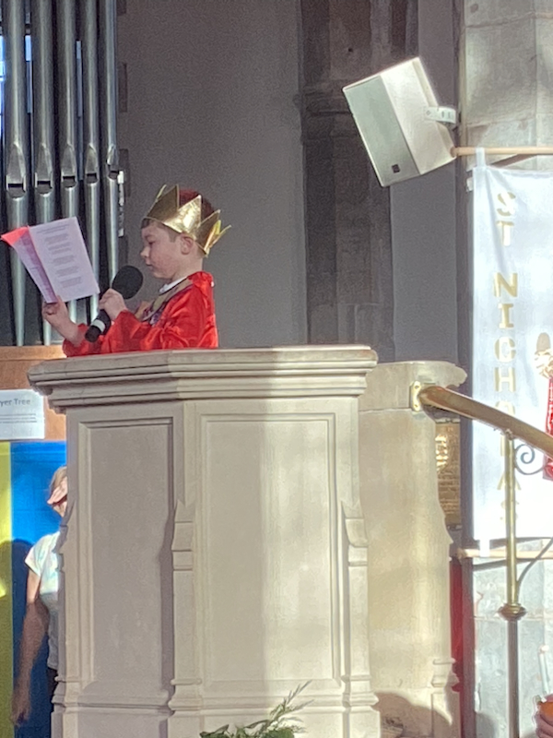
The children performed the tableau during our Christingle service, speaking and performing in front of family and friends. All singing the first verse of Away in a Manger.

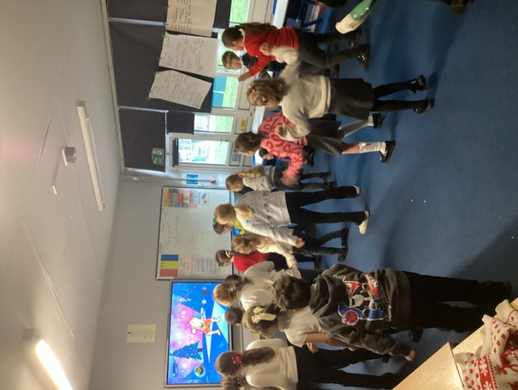
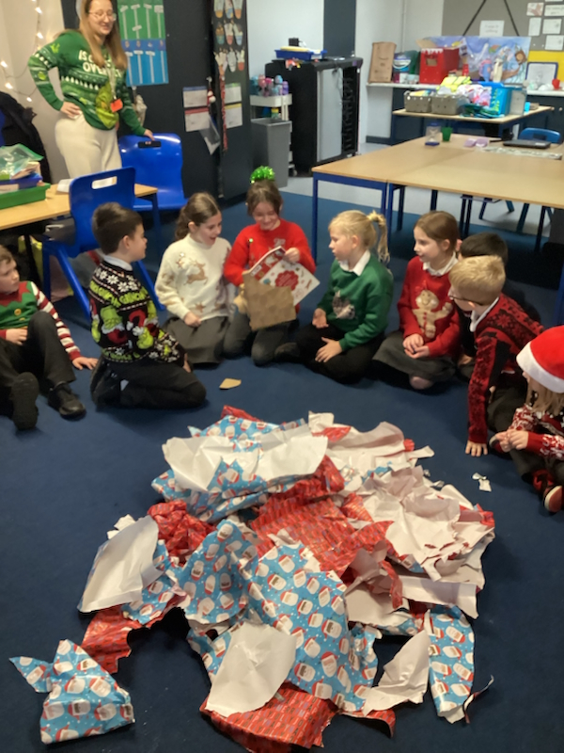
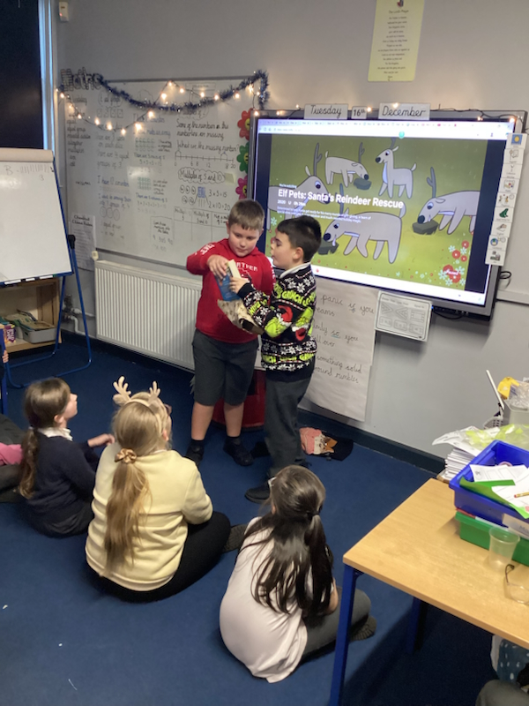
Everyone enjoying their Christmas themed day that included a party, playing games and dancing with their friends. Each class also received a present from the school, for all the children to enjoy whilst in class.

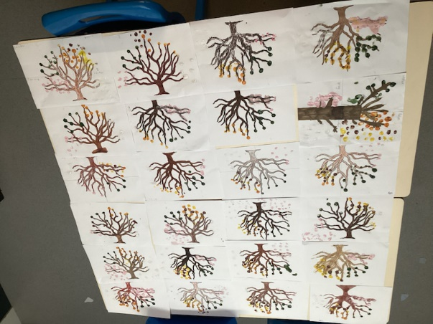
Finger painting is something all the children loved as they enjoyed the sensory textures, showing how they see the different seasons using their imagination.

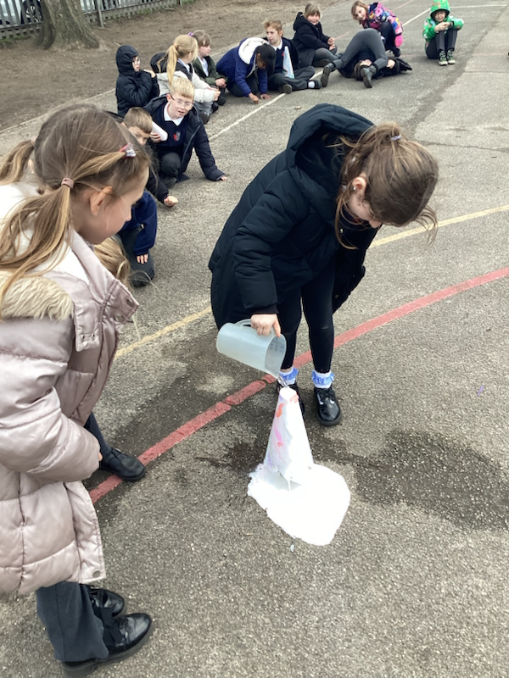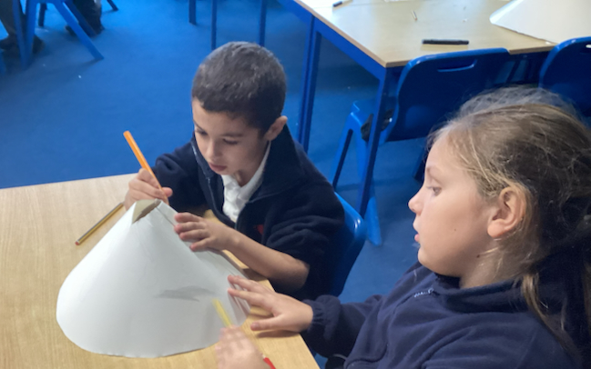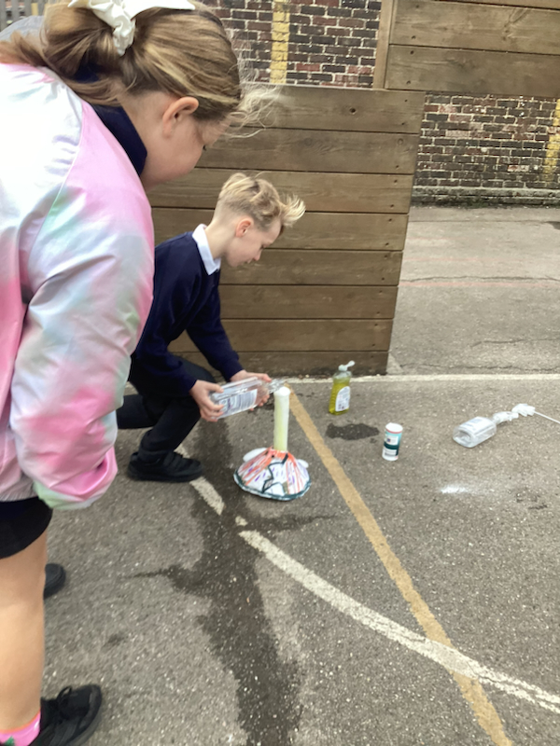

Designing and making volcanos was something the children had the pleasure to do, once everyone had finished, we took them to the playground where we mixed ingredients together for the volcanoes to erupt.
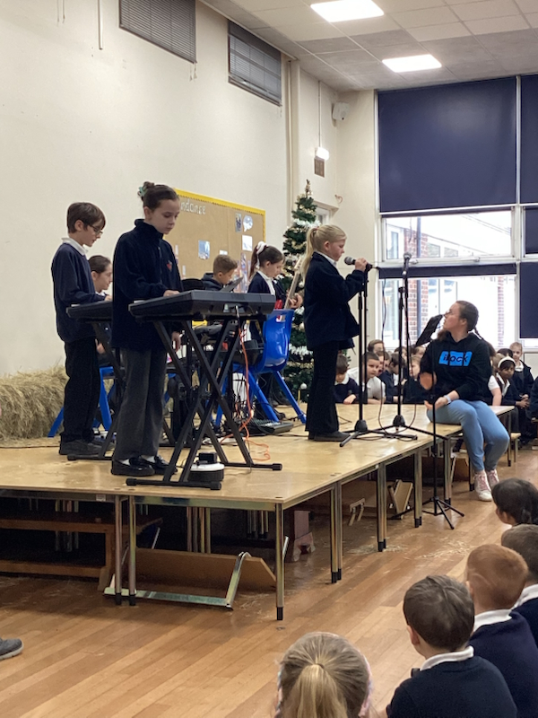
Children that are part of IRock, put on a performance for friends and family. Singing and playing musical instruments that they are learning.

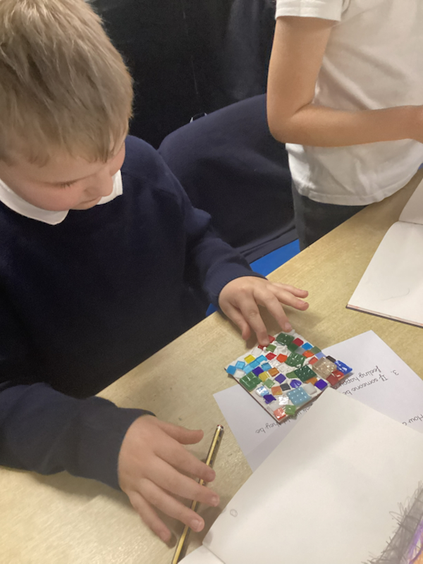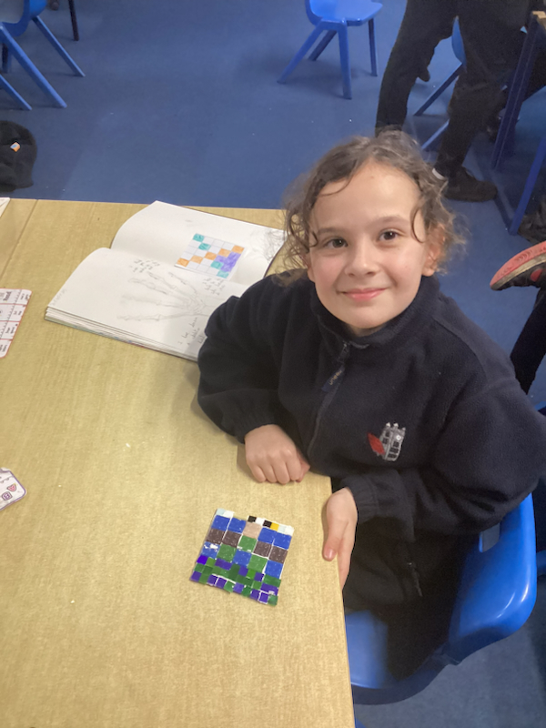
During a term the children were learning about the Romans. For a reactive activity, they all made Roman mosaic pieces. Using different shapes, sizes and colours of tiles to put together a beautiful master piece.
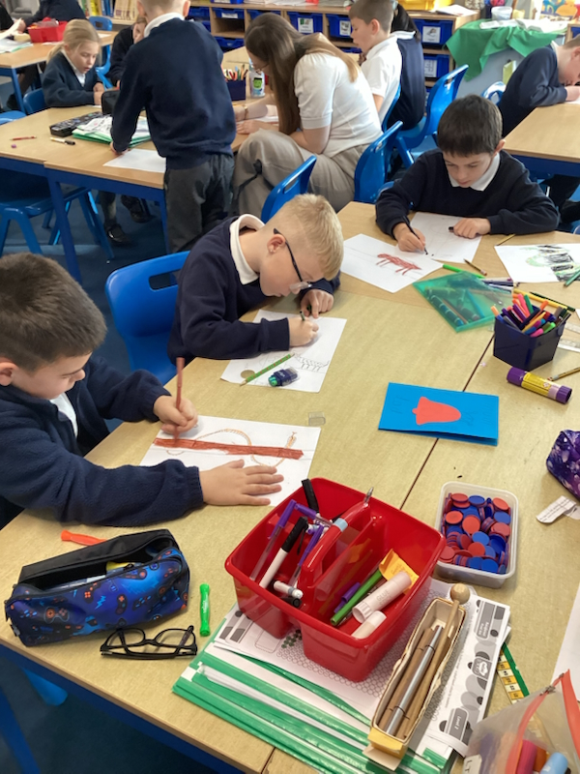
The children beautifully made Christmas cards for a charity who distribute them to care homes, giving warmth and showing love to their community.

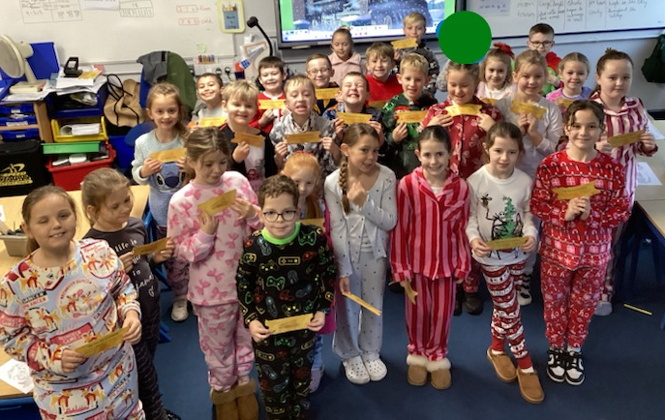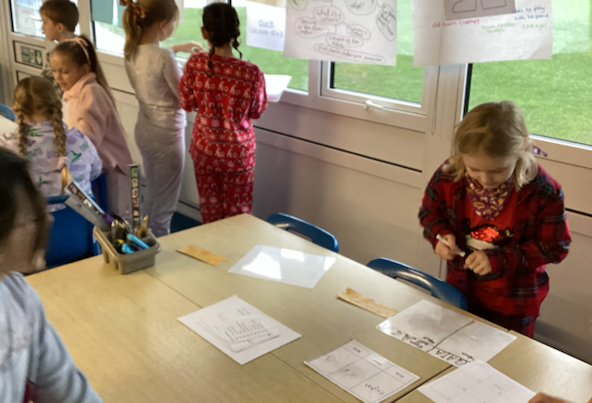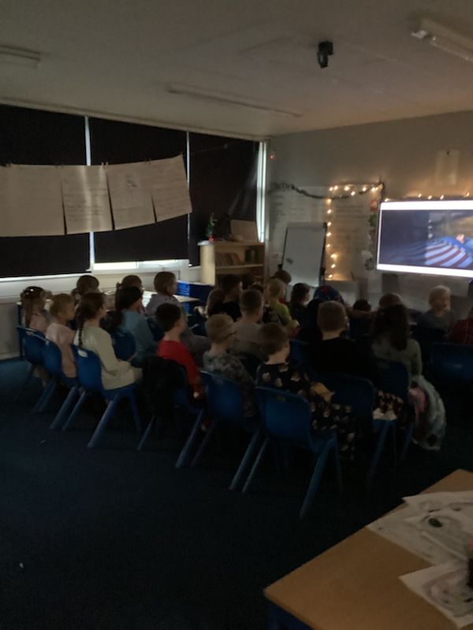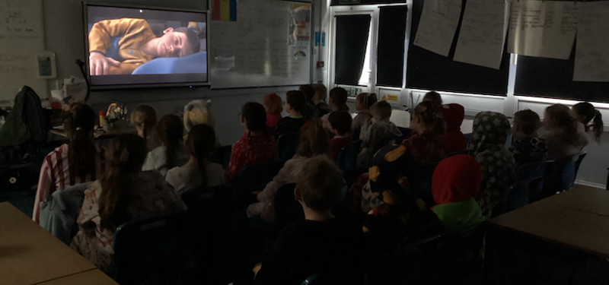
We had a Polar Express day that involved some fun activities such as finding clues, drinking hot chocolate whilst watching the film and arranging the classroom to look like they were sitting together on the train.

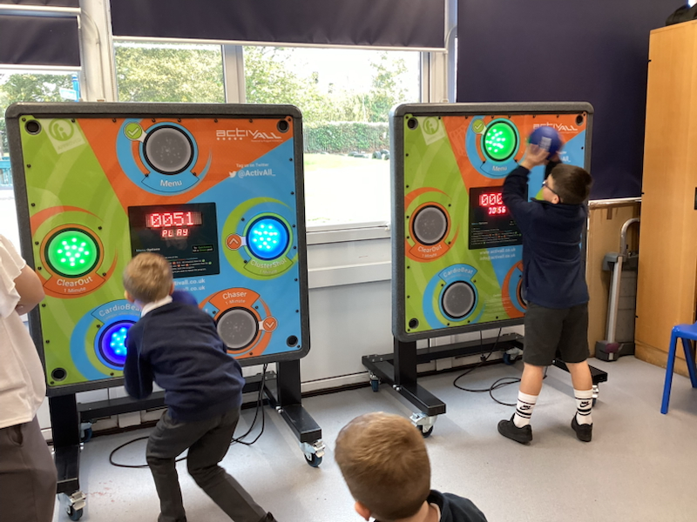
The children were set a challenge to see how many targets they could hit in 30 seconds on our Active walls.
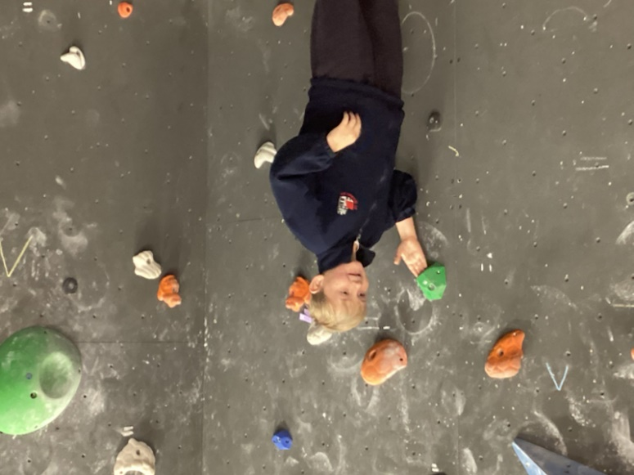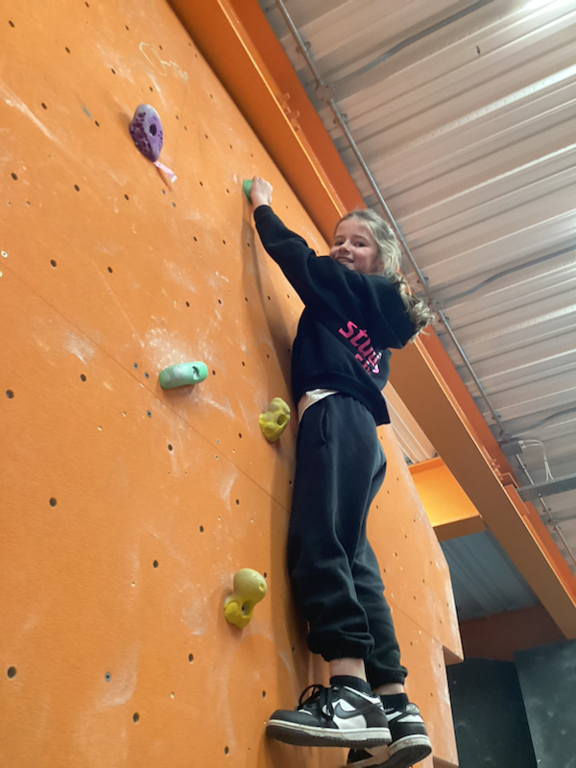
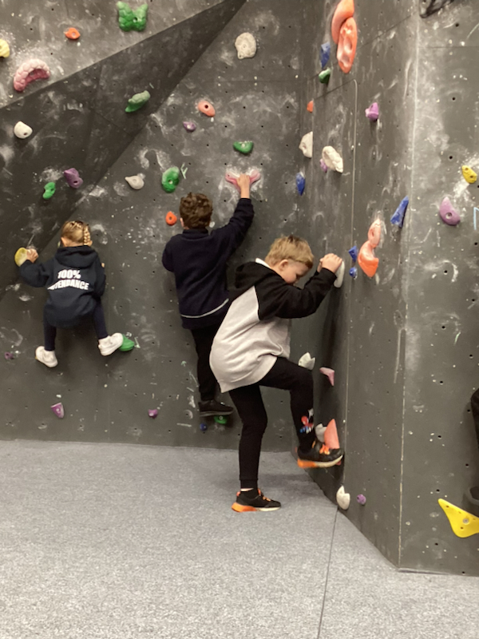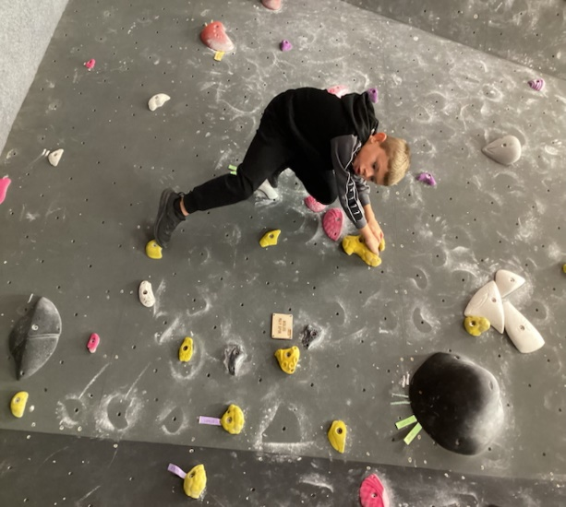
The children had the opportunity to go to F51 to try bouldering. Using all of their body strength to help them get to the top and to experience a new challenge.
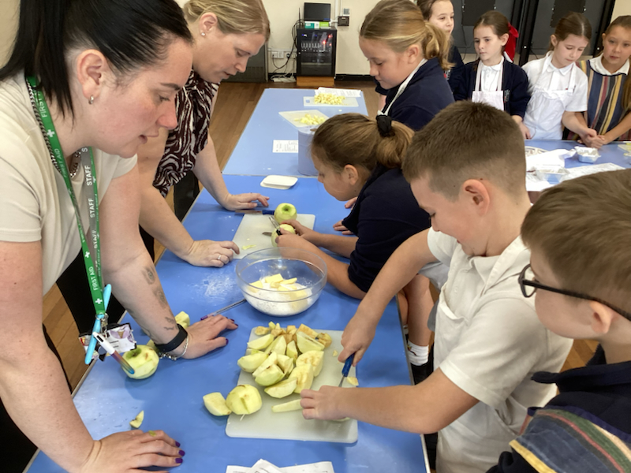
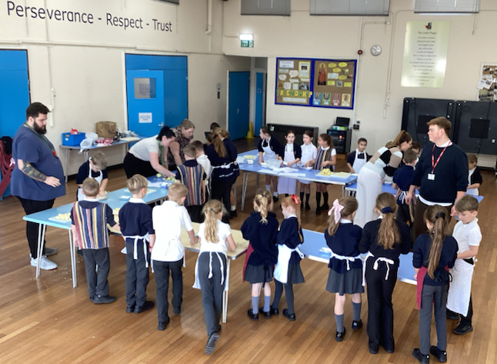
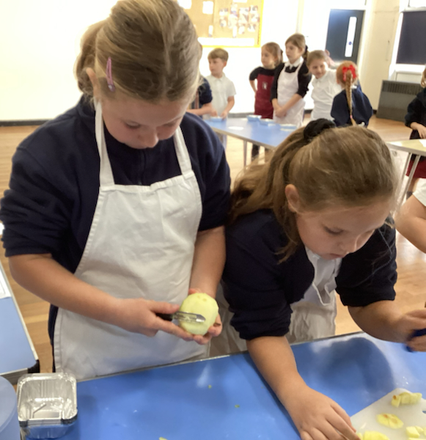
Cutting, slicing and dicing apples to make crumble as part of our DT was an activity the children loved. The children had to peel and chop the fruit, weigh the ingredients out onto scales to make sure they had the correct amount.
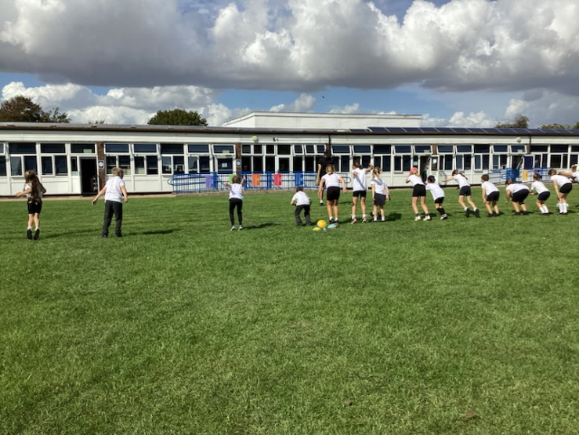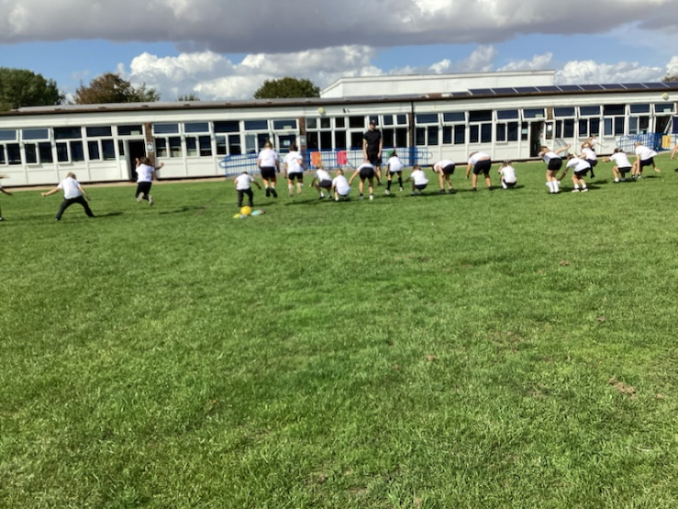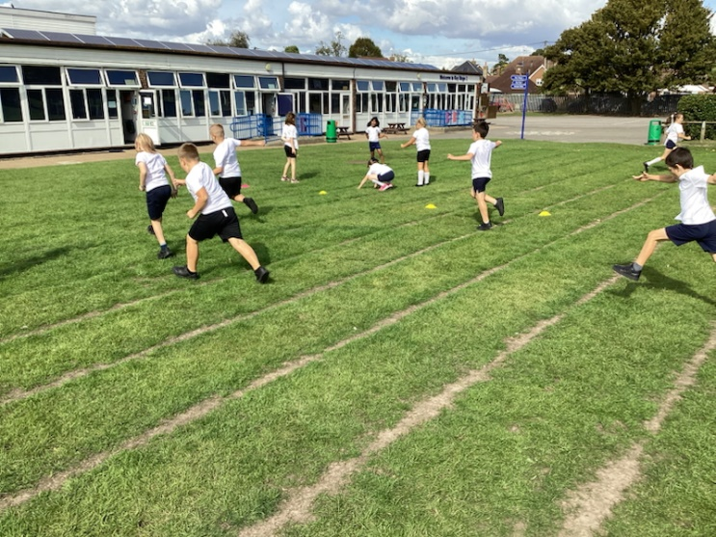
Children learning how to gain small margins through subtle technique changes.
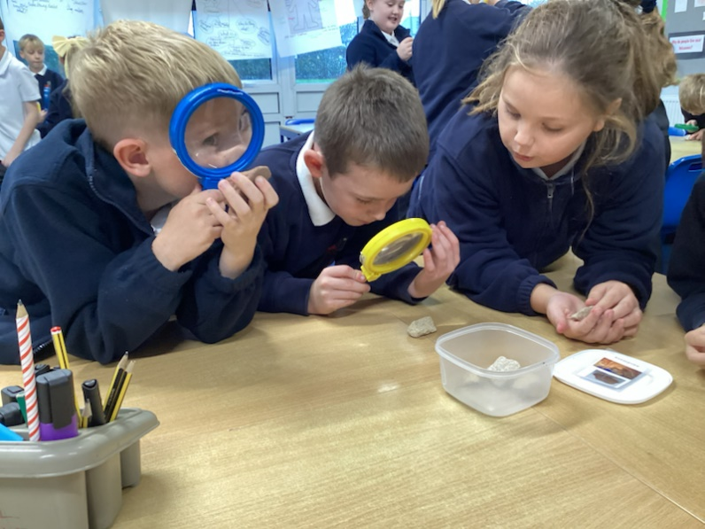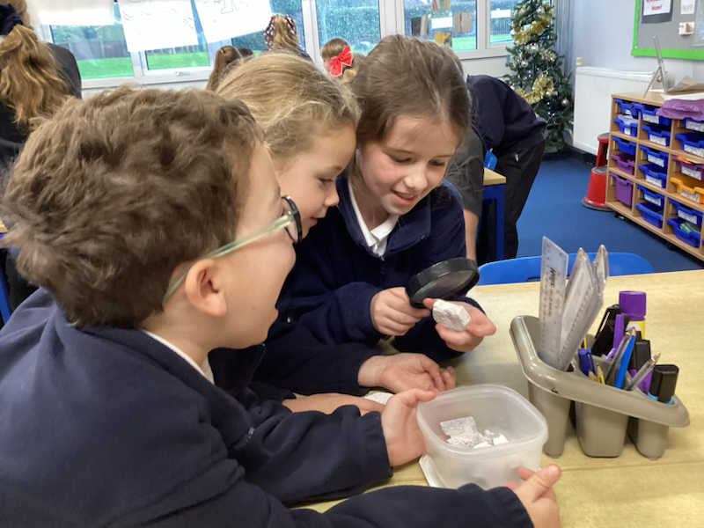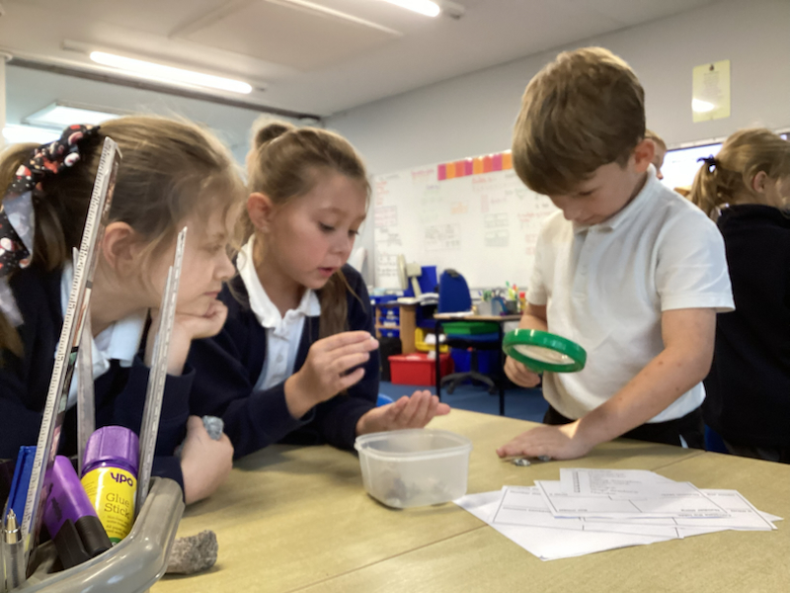
In science the children have been learning about different types of rocks and what materials makes these specific patterns.
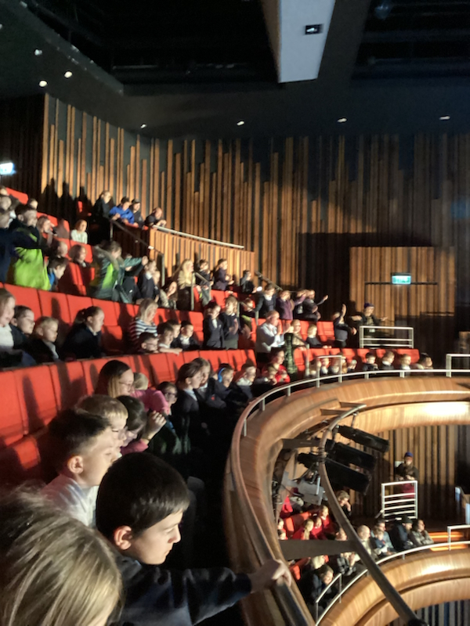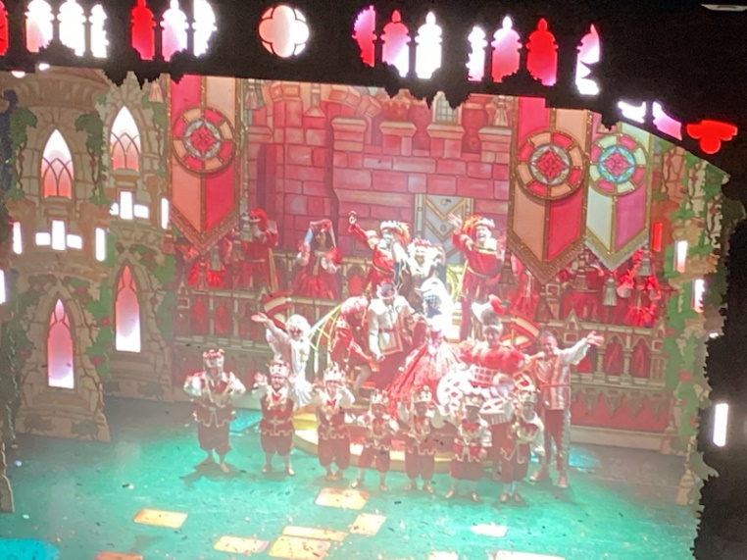
A KS2 trip took us to the pantomime in Canterbury to watch Snow white and the seven dwarfs. All children loved this experience and joining in on the singing and shouting out. Oh yes, they did!
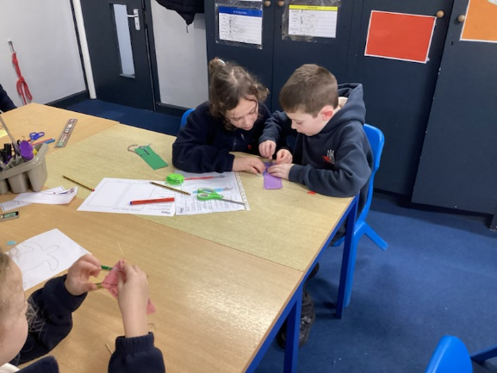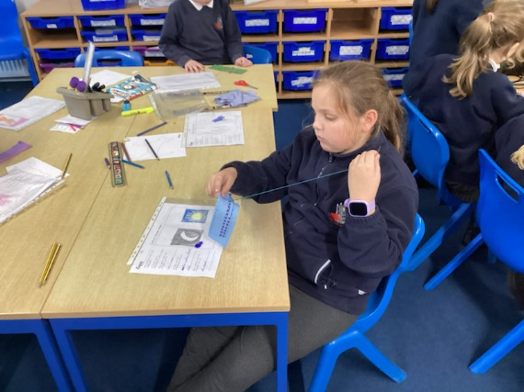
This term is DT week and the children have been learning how to sew, using cross stitching. At the end of their week the children made a cushion.
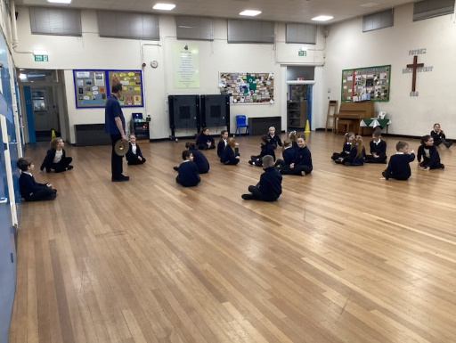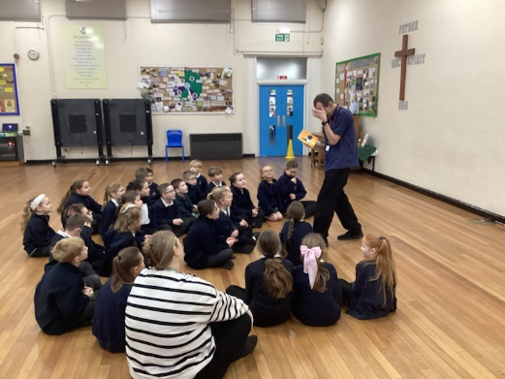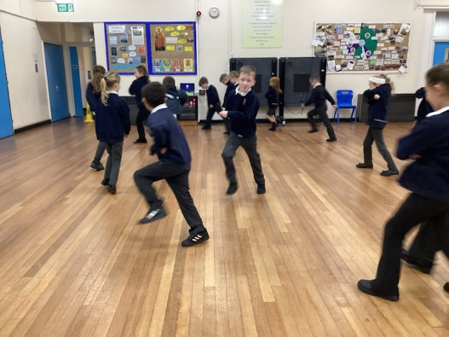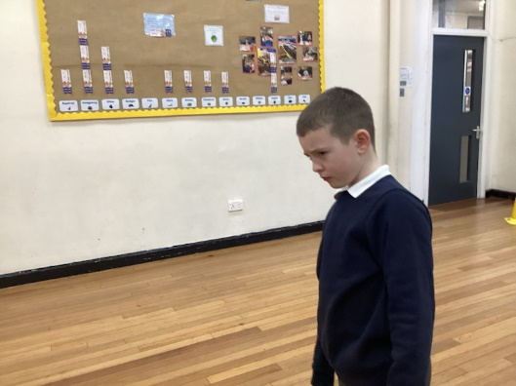
As the children have been reading a book called The Queens Nose, we taken part in a workshop to teach the children how emotions and actions can be explored through drama.

