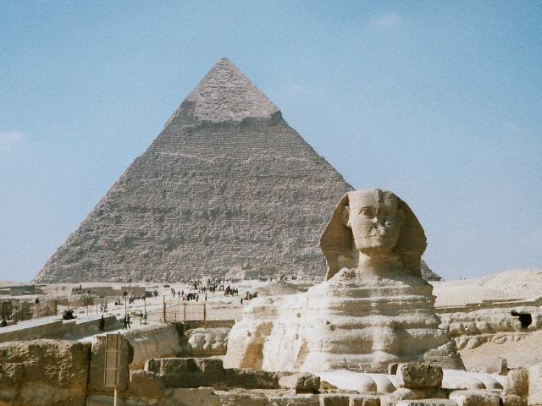Co

Maths

**Division**

* Efficient division using multiplication facts and written methods
* Divide 2 digits by 1, divide 3 digits by 1

**Fractions**:

* What is a fraction and equivalent fractions.
* Fractions greater than 1, counting in fractions
* Adding and subtracting 2 or more fractions
* Subtracting from whole amounts
* Fractions of quantities

**Shape**

* Identify angles
* Compare and order angles
* Triangles
* Quadrilaterals
* Lines of symmetry
* Symmetric figures
* Describe position
* Draw on a grid
* Move on a grid
* Describe movement

Art – Sketching

* Create all the colours they need through mixing.
* Can record and explore ideas in a variety of ways, using sketchbooks.
* Can create original pieces that are influenced by studies of others.

English – Writing

Poetry –

* Narrative poetry.
* Similes.
* Acrostic poems

Fiction – Marcy and The Riddle of the Sphinx (Focus on story openings)

* Expanded noun phrases – adjectives and prepositional phrases.
* Use of standard English forms of verbs (EG: we were instead of we was).
* Use of more than one clause by using conjunctions.

Non-Fiction – Egyptian Gods

Design and Technology – Fastenings

* Design and create a book sleeve
* Explore a variety of fastenings
* Select the most appropriate for their design

Music – Composing

PE – Gymnastics and Basketball

PSHCE – Health and Well Being

French – Weather and the Water Cycle

Year 4 – Spring Term 2

Ancient Egypt

Computing

* E-Safety – how to develop healthy, respectful and empathetic relationships online
* Web Design

Science – States of Matter

* Compare and group materials together, according to whether they are solids, liquids or gases.
* Observe that some materials change state when they are heated or cooled, and measure or research the temperature at which this happens in degrees Celsius (°C).
* Identify the part played by evaporation and condensation in the water cycle and associate the rate of evaporation with temperature.

Topic- Ancient Egypt

* How important was Cleopatra?
* What was the importance of the River Nile and how did it determine where Egyptians lived?
* Research Egyptian Gods
* Can I explain the ancient Egyptian ritual of mummification?
* Use secondary sources of information.

RE- Salvation? Why do Christians call the day Jesus died ‘Good Friday?’

* Offer suggestions about what the narrative of the Last Supper, Judas’ betrayal and Peter’s denial might mean.
* Give examples of what the texts studied mean to some Christians.
* Make clear links between Gospel texts and how Christians remember, celebrate and serve on Maundy Thursday, including Holy Communion.
* Describe how Christians show their beliefs about Jesus in their everyday lives: for example, prayer, serving, sharing the message and the example of Jesus.
* Raise questions and suggest answers about how serving and celebrating, remembering and betrayal, trust and standing up for your beliefs might make a difference to how pupils think and live.