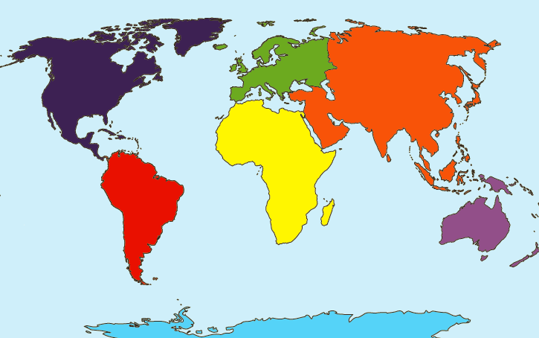

**Maths**

**Addition and subtraction**

- add and subtract 1s

- 10 more and less

- add and subtract 10s

- add 2 digits and 1 digit

- subtract 1 digit from 2 digits

**Multiplication**

**and division**

- recognise equal amounts

- Make equal groups

- add equal groups

- the multiplication symbol

- Multiplication from pictures

- use arrays

Year 2’– Fox, Hare and Rabbit Class

Term 2 Curriculum Map

**DT**

* Food tasting
* Healthy eating
* Designing and evaluating
* Food hygiene
* Making wraps

**Music Objectives**

* Use their voices expressively and creatively.
* Play tuned and untuned instruments.
* Listen and understand music.

**Science Objectives**

Children will be observing closely, using simple equipment.

Can they perform simple tests?

Can they identify and classify different materials?

Can they gather and record data to help in answering questions?

Can they compare how things move on different surfaces?

**RE Incarnation**

* Recognise that incarnation is part of the ‘Big Story’ of the Bible.
* Tell the story of the birth of Jesus and recognize the link with incarnation – Jesus is the ‘God on Earth’.
* Give at least two examples of ways in which Christians use the nativity story in churches and at home.
* Think, talk and ask questions about the Christmas story and the lessons they might learn from it.

**Geography Objectives**

* Understand where in the world we live.
* Name and locate the world’s continents.
* Name and locate the world’s oceans.
* Identify human and physical features of a continent.
* Understand how each continent is special.

**PE**

Developing our running and jumping skills.

Finding different ways of taking off and landing.

To perform sequences in gymnastics with clear beginnings and endings.

.

**PSHE Objectives**

* Understand the importance of rules and consequences of not following them.
* Caring for the needs of babies, young children and animals.
* Explore similarities and differences with an introduction to democracy.

**Art Objectives**

* Know about the work of a range of artists.
* Make links between their own work and the work of artists.
* Develop techniques in colour, pattern, texture, line, shape, form and space.
* To develop their control and use of materials creatively.

**Computing objectives**

* Understand what an algorithm is.
* How to program algorithms.
* How to develop algorithms to be more efficient.
* Introduction of loops.

**English**

This term we will be reading The Lighthouse Keepers Lunch. Over the term, we will be writing instructions, a letter and a narrative. Towards the end of the term, the children will be writing their own nativity plays. 