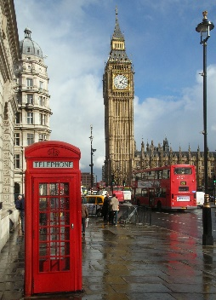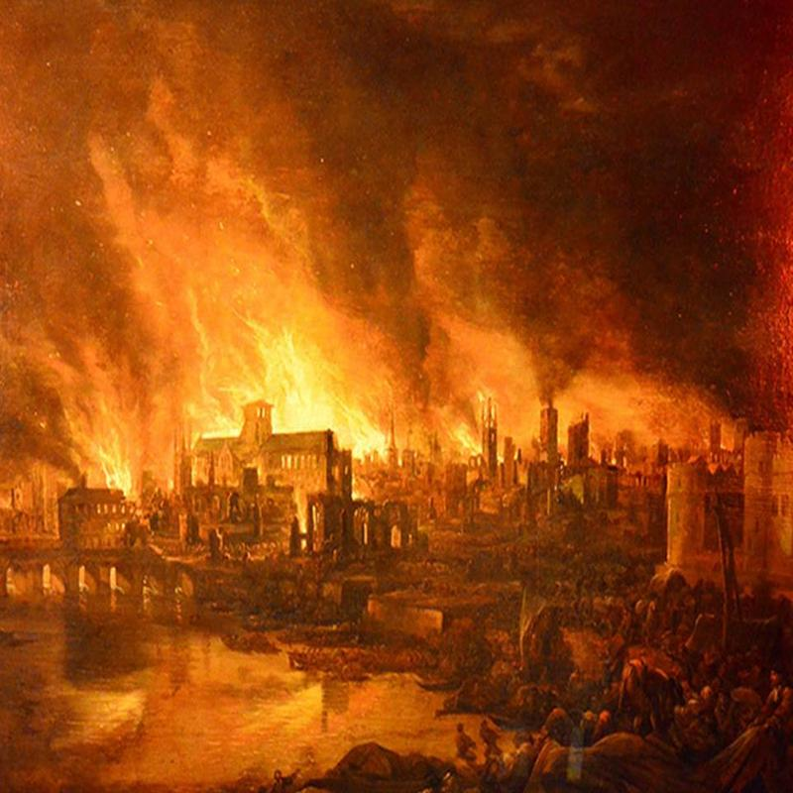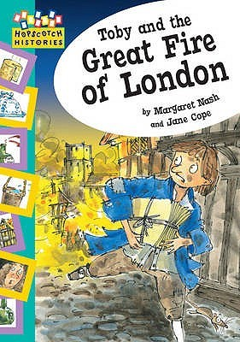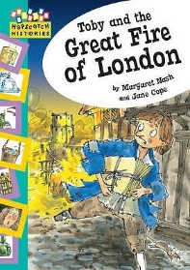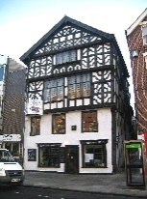

**English**

We are reading: Toby and the Great Fire of London

We are writing: a setting description, recount, poem and diary

We will: use punctuation correctly and forming letters correctly on the line.

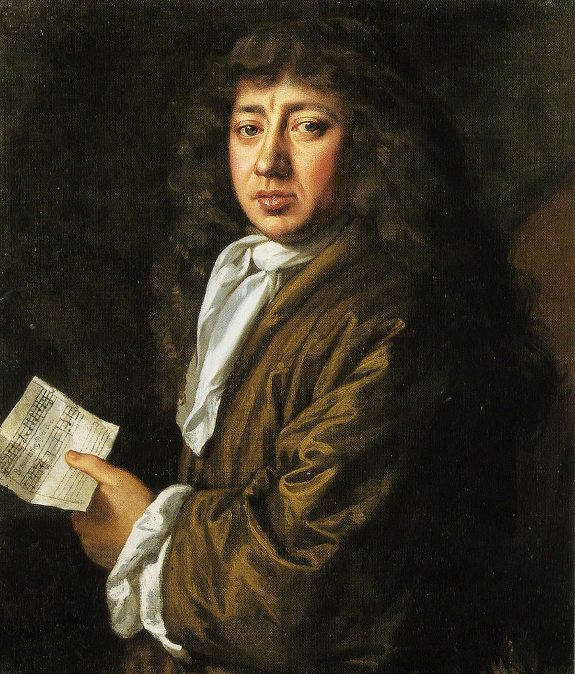

**Maths**

Count objects to 100

Read and write numbers to 100

Partition tens and ones

Order and compare objects

Order and compare numbers to 100

Fact Families

Know the number bonds to 100

Add and subtract 2 digit numbers and ones

**DT Objectives**

* To know the stability of different shapes.
* To know the strength of different materials.
* To design and plan a structure.
* To make a structure.
* To evaluate a structure.

**PE**

Developing our spatial awareness.

Finding different ways of travelling.

Using a range of equipment when travelling.

Use levels and movement to create fire dances.

**Science Objectives**

Can they link to buildings and the materials used?

Can they Identify and compare the suitability of a variety of everyday materials, including wood, metal, plastic, glass, brick, paper and cardboard for particular uses?

Can they find out how the shapes of solid objects made from some materials can be changed by squashing, bending, twisting and stretching?

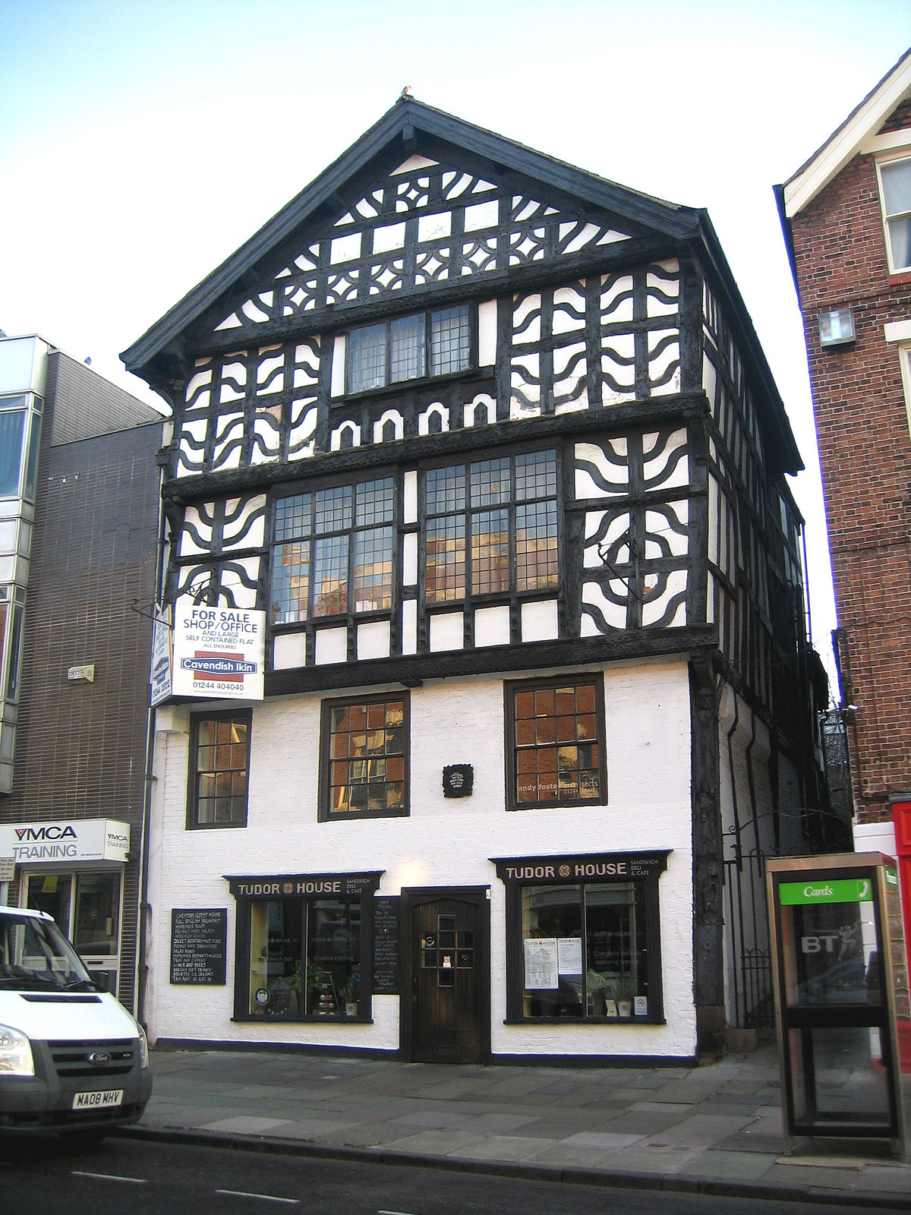

**History Objectives**

Key Events in History – Great Fire of London, Guy Fawkes and Bonfire Night

Can they recount facts from an historical event?

Can they show an understanding of chronology and order key events?

Can they comparing London now and then?

**RE Creation**

* Retell the story of creation from Genesis 1:1–2.3 simply.
* Recognise that ‘Creation’ is the beginning of the ‘big story ’of the Bible.
* Give at least one example of what Christians do to say thank you to God for the Creation.
* Know the importance that Christians attach to a day of rest

**PSHE Objectives**

* To understand that families are composed of different people who often each other care and support.
* To understand how people, show their feelings and how to respond.
* To know the convention of manners and develop an understanding of self-respect.

**Computing objectives**

* Recognising parts of a computer and explaining their uses.
* To know how technology is controlled and follows instructions.
* To explain where computers are used.

Year 2 – Fox, Hare and Rabbit Class

**Music Objectives**

* Sing ‘London’s burning’.
* Understand dynamics and pitch.
* To explore, choose and organize sounds.
* To create their own composition.

**Great Fire of London**