Monday 1st March 2021:
Today’s focus: Can I identify and explain the author’s use of language.

Look through Chapter 1 – create a role on the wall of Blunt. What can you identify about his character (personality and looks)? We will continue to build on this as we read the book further.

Why do you think Blunt is portrayed as a negative character? Why do you think the author has named a character Mr Blunt? Make a prediction about what this character may be like further on in the novel.

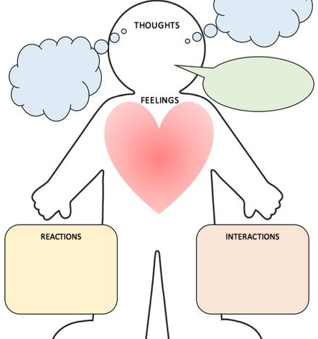

Tuesday 2nd March 2021:
Today’s focus: Can I identify and explain the author’s use of language.

Use an A4 sheet of paper and fold it in half landscape. Draw a picture of what you think Alex looks like just now and, as you read on and gather more information about Alex, you will draw another image how you now think Alex looks like. You will be able to use adjectives to describe both how Alex looks and his qualities.

What Alex looks like after reading Chapter 1

What Alex looks like after reading a number of chapters

Wednesday 3rd March 2021
Today’s focus: Can I answer questions using evidence from the text?

Read or listen to chapter 2 – Heaven for Cars

Now answer these questions about what you have read.

1. Make a prediction; where do you think the chapter ‘Heaven For Cars’ may be set?

2. How many years has Alex owned his bike?

3. Why do you think Ian rider said that a comprehensive school would be more of a challenge than a private school?

4. Why did the J.B Stryker advert catch Alex's attention over any other?

5. Find and copy the personification used on page 24.

6. How did Ian Rider die? Why do you think that? Use evidence from the text to support your answer.

7. What helped Alex when defending himself against the two men?

8. What does the author mean at the end of the chapter when he uses the phrase: 'He could have been looking a lot worse’?

Thursday 4th March
World Book Day – Please see other activities for today.

Friday 5th March 2021
Today’s focus: Can I infer a characters’ feelings and emotions?

Questioning
Think of five questions you would like to ask Alex Ryder. Write them down and send them to me.

1.)

2.)

3.)

4.)

5.)

Add to the character profiles of Blunt and Alex too. What else do we know about them now we’ve read chapter 2.

