Monday – First catch your dragon | Tuesday – Inside the Nursery | Wednesday |  | Thursday | Friday
Lesson 1- what does the map tell you? Bullet point 5 pieces of information you get from the map.  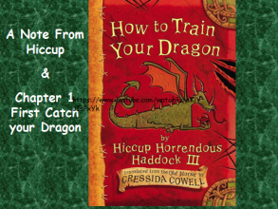  Make a prediction based on the pictures of the characters from the books.  https://www.youtube.com/watch?v=uWhNzQUfmSE  Listen to part 1 and answer the focused reading questions on the powerpoint  Main Task – discuss imperative verbs and time connectives. Order and re-write a set of instructions using these words or synonyms | https://www.youtube.com/watch?v=x6l3VzawaUc – Chapter 2/Part 1  https://www.youtube.com/watch?v=kBBFwWRG4ZE – Chapter 2/Part 2  Listen to the chapter and answer the questions in focused reading books – discuss any unfamiliar vocabulary  Design their own dragon – discuss adjectives to use that are powerful | 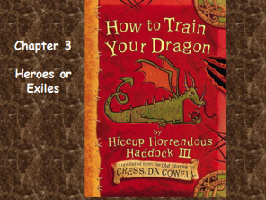  Rewrite the escape | 9.00am World Book Day Virtual Assembly  Today they are going to write instructions for how to train their dragon following their design on Tuesday  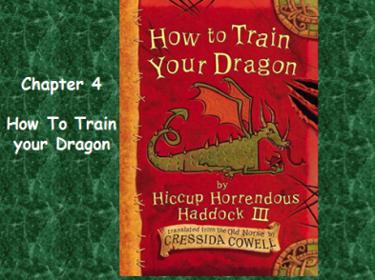 |  | Write the next section of the text using inverted commas. Can they write what they think will happen in chapter 6 after reading chapter 5.
Hiccup Horrendous Haddock the Third is a smallish Viking with a longish name. Hiccup's father is chief of the Hairy Hooligan tribe which means Hiccup is the Hope and the Heir to the Hairy Hooligan throne - but most of the time Hiccup feels like a very ordinary boy, finding it hard to be a Hero.
In the first How to Train Your Dragon book Hiccup must lead ten novices in their initiation into the Hairy Hooligan Tribe. They have to train their dragons or be BANISHED from the tribe FOR EVER!
But what if Hiccup's dragon resembles an ickle brown bunny with wings? And has NO TEETH? The Seadragonus Giganticus Maximus is stirring and wants to devour every Viking on the Isle of Berk . . .
Can Hiccup save the tribe - and become a Hero? Blurb – general plot

https://www.youtube.com/watch?v=oKiYuIsPxYk

