25/2/2021 (Thursday) – L.I. Can I calculate perimeter?
https://whiterosemaths.com/homelearning/year-5/week-11-measurement-perimeter-area/ - Calculate perimeter
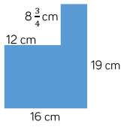
- Find the perimeter of these shapes.
Orange shape perimeter:
Green shape perimeter:
Blue shape perimeter:
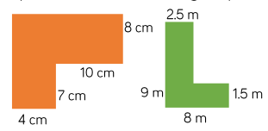
.

- Here is a square inside another square.
The perimeter of the inner square is 16cm. The outer square’s perimeter is four times the size of the inner square. What is the length of one side of the outer square? How do you know? What do you notice?
__________________________________________
__________________________________________
__________________________________________

- The value of c is 14m. What is the total perimeter of the shape? (4c is the same as writing 4 x c or 4 lots of c)

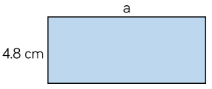
- The blue rectangle has a perimeter of 38cm. So what is the value of a?

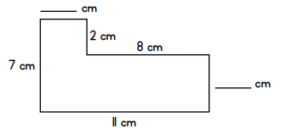

- Use the lengths given to complete the missing length. Then calculate the perimeter of this shape.

Extra challenge – Can you write your own word problem involving perimeter? Send it to Mrs Bader or Miss Welsh to solve!

