25/2/2021 (Thursday) – L.I. Can I measure the perimeter of a rectilinear shape?
https://whiterosemaths.com/homelearning/year-5/week-11-measurement-perimeter-area/ - Perimeter of rectilinear shapes
- Find the perimeter of these shapes.
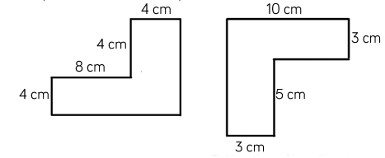

- This shape is made up of 3 identical rectangles. Calculate the perimeter of the shape.
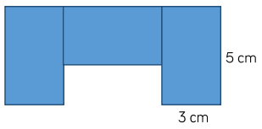

- How many different rectilinear shapes can you make with a perimeter of 24cm? How many sides do they each have? Can you find the longest and shortest side?

- Here is a rectilinear shape. All of the sides of the shape are the same length and the same number of centimetres. Which of these lengths could be the perimeter of a shape?
48cm 36cm 80cm 120cm 66cm
Can you think of any other answers which could be correct? ________________________
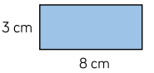
- Amir has some rectangles all the same size.

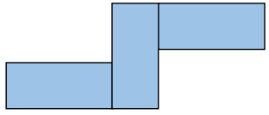

He makes this shape using his rectangles.
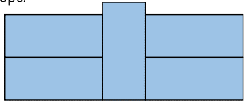
What is the perimeter? ______________
He makes another shape using his rectangles. What is the perimeter of this shape?
_______________________

Use his rectangles to create your own shape and calculate its perimeter.

