24/2/2021 (Wednesday) – L.I. Can I measure the perimeter of a rectangle?
https://whiterosemaths.com/homelearning/year-5/week-11-measurement-perimeter-area/ - Perimeter of rectangles.
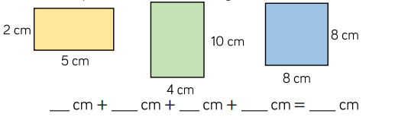
- Calculate the perimeter of these rectangles.

- Eva is finding the perimeter of a rectangle. Use Eva’s method to calculate the perimeter of these rectangles.

- Always, sometimes or never. When all the sides of a rectangle are odd numbers the perimeter is even? Prove your answer.
__________________________________________________________________________________________________________________________________
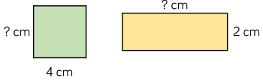
- Each of these shapes have a perimeter of 16cm, calculate the length of the missing sides.

- Here is a square. Each of the sides is a whole number of metres. Which of these lengths could be the perimeter of the shape?
24m 34m 44m 54m 64m 74m
Why could the other values not be the perimeter of the shape?
________________________________________________________
- The width of a rectangle is 2m less than the length. The perimeter of the rectangle is between 20 and 30m. What could the measurements of the rectangle be? Draw all the rectangles that fit these rules.
Use 1cm = 1m,

