23/2/2021 (Tuesday) – L.I. Can I measure perimeter on a grid?
https://whiterosemaths.com/homelearning/year-5/week-11-measurement-perimeter-area/ - Measure perimeter on a grid.
- Draw these shapes on square paper and measure their perimeter. Count the number of squares to help you.
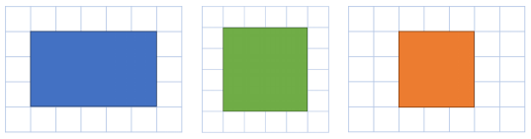

- On your squared paper draw two rectilinear shapes (shapes which are made up of straight lines) with a perimeter of 28cm. Try to draw at least one of your shapes as something other than a rectangle, like these examples..

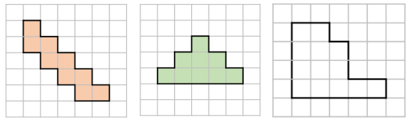
- Draw these shapes on your squared paper and order them from the smallest to largest perimeter.

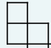
- You have 10 paving stones which you can use to design a patio. Each stone measures a metre square. The stones must be joined to each other so that at least one edge is joined corner to corner (see image). Show which design would give the largest perimeter and which would give the smallest.

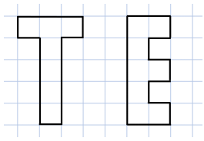
- Which of these shapes has the longest perimeter?
Explore other letters which could be drawn as rectilinear shapes on squared paper. Could you make a word and find out the perimeter of this word?

