22/2/2021 (Monday) – L.I. Can I measure perimeter?
https://whiterosemaths.com/homelearning/year-5/week-11-measurement-perimeter-area/ - Measure perimeter
- Measure the perimeter of these rectangles.
Remember to include the unit of measurement you used (e.g. cm / mm)
Perimeter:

Perimeter:
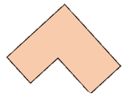
- Measure the perimeter of these shapes.
Perimeter:
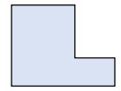
Perimeter:
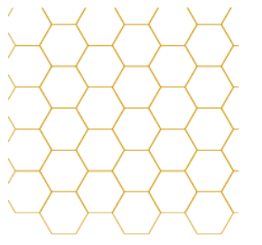
- Each regular hexagon has a side length of 1cm. Can you create a shape with a perimeter of 22cm?

- Can you measure the perimeter of some different objects around your house? Here are some ideas to start you off (for some of these you may want to borrow a tape measure from a grown up if you have one): A piece of A4 paper, your bed, a window. Try to think of at least 5 objects.

