Year 4 Remote Learning – Week 5
English

Subject | Work at home ideas
Reading  A daily story will be uploaded | - Reading Plus: log on and complete the readings provided.  - Remember ALL reading is important! Read any books you have at home, share with your family. Perhaps you could read to brothers and sisters too.  - Focused reading questions will be uploaded to Dojo twice throughout the week
Spelling | - Year 4 spellings on class Dojo as per usual. Some extra practice words might also be included.
English | Monday –  You will need the pictures of the different settings
Tuesday–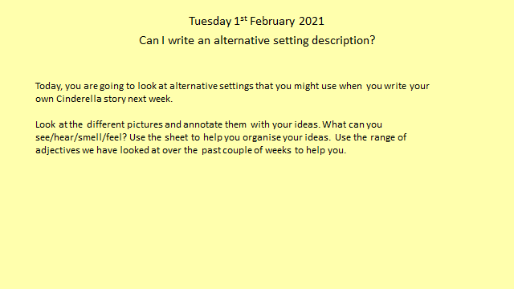
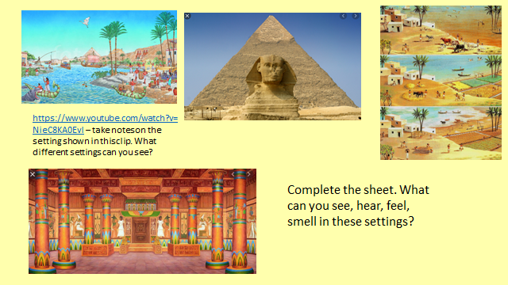

Wednesday –
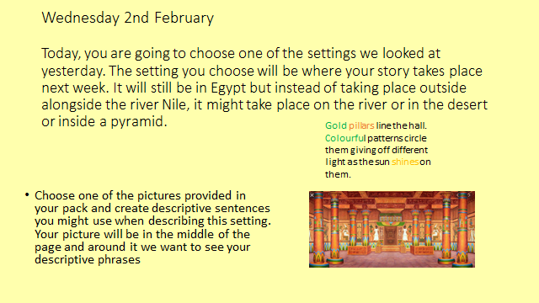

Thursday –
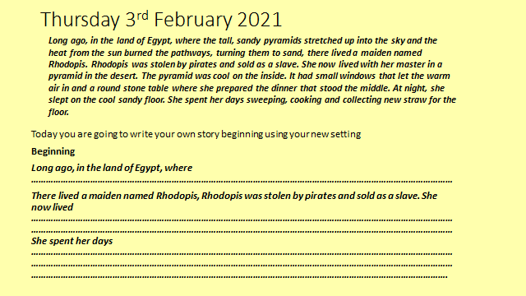
 | Friday – 