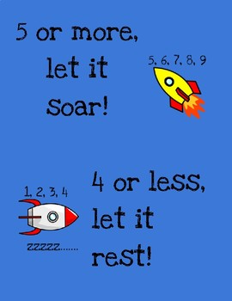
27/1/21 (Wednesday) – Can I round numbers, including decimals?
When you are asked to round a number follow these steps:
- Identify the digit with the given place value.
- Underline the digit next to it.
- Round to the nearest 10. Remember if your underlined digit is 5 or more let it soar, 4 or less let it rest.
- Remove all digits after the given place value.

1.
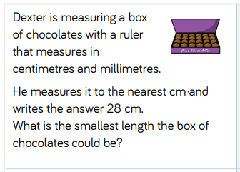
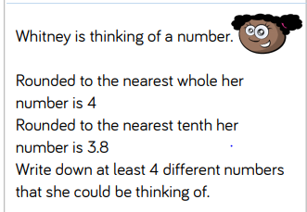
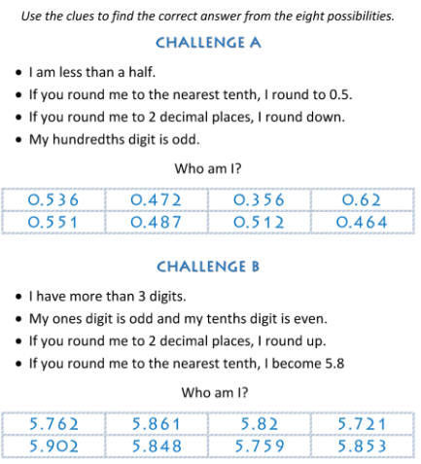
2.
3.

4. A number between 11 and 20 with 2 decimal places rounds to the same number when rounded to one decimal place and when rounded to the nearest whole number?
What could this be?
Is there more than one option? Explain why.

