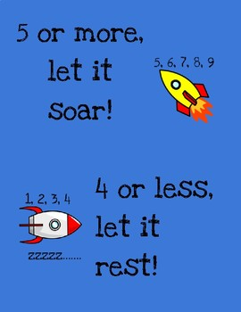
26/1/21 (Tuesday) – Can I round numbers, including decimals?
When you are asked to round a number follow these steps:
- Identify the digit with the given place value.
- Underline the digit next to it.
- Round to the nearest 10. Remember if your underlined digit is 5 or more let it soar, 4 or less let it rest.
- Remove all digits after the given place value.
Round 32.081 to the nearest tenth.
- 32.081
- 32.081
- 32.081(5 or more, let it soar)
- 32.1

Round 4.561 to the nearest hundredth.
- 4.561
- 4.561
- 4.561 (4 or less, let it rest)
- 4.56

Number | 2d.p.(hundredths) | 1d.p. (tenths) | Nearest 10 | Nearest 100
512.715
623.819
293.214
90.4328
678.631
9864.237
43.830

