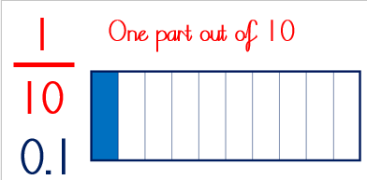
25/1/21 (Monday) – Can I understand the relationship between tenths, hundredths and thousandths?
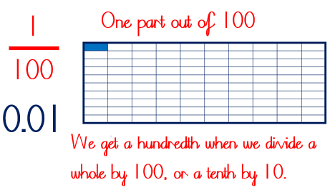
2.308
This number has 2 ones, 3 tenths, 0 hundredths and 8 thousandths.
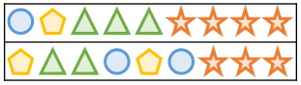
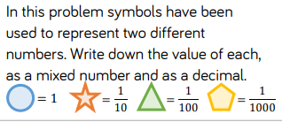
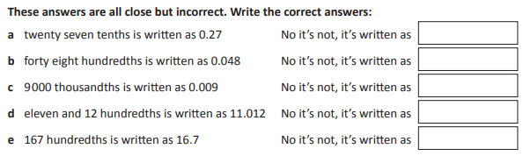
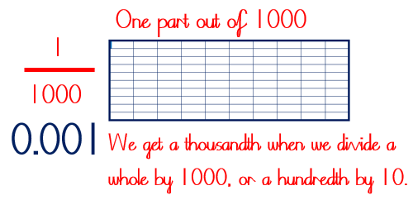
Here it is on a place value chart:
o | tths | hts | tths
2 | 3 | 0 | 8

