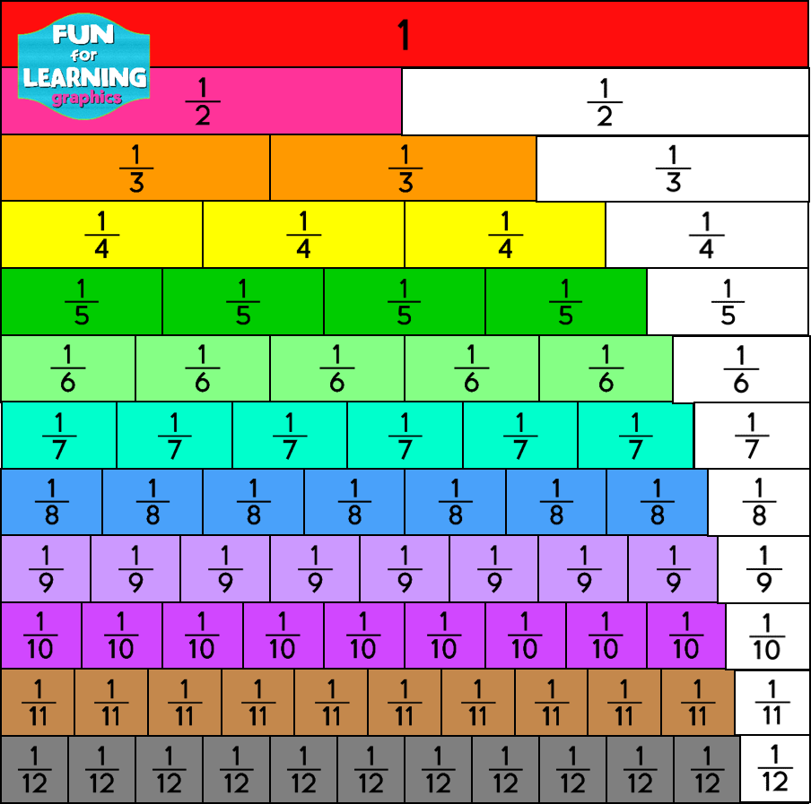[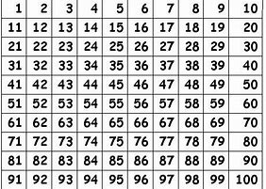](https://www.bing.com/images/search?view=detailV2&ccid=V%2bYtW2rB&id=90498A3614495542383C0F4BABF23F33E825D4C2&thid=OIP.V-YtW2rBrudcT2a2UaTXWQAAAA&mediaurl=https%3a%2f%2fthewordsmythe.files.wordpress.com%2f2013%2f10%2f100square.jpg&exph=341&expw=460&q=100+square&simid=608018655444535942&selectedIndex=0)

Maths Support Mat

