Foundation Stage Home Learning
We are now using the Oak National Academy Website for our home learning activities. Please find below a link to the activities we would like the children to complete. Remember, everything we provide is here to give you ideas. If you have been completing other things that work for your child, please continue to do so.
This is the link you will need:https://www.thenational.academy/online-classroom/reception#schedule
Then scroll down to find week 4 which is dated 11th May then click on Monday and you will have 3 lessons an English, Maths and Foundation lesson. You have the same format for each day of the week. In the tables below it shows an overview of the learning for each day the lesson names on the site are different just make sure you are on correct week and day as above.
English: Week 4 Traditional Tale: Hansel and Gretel
Monday | Tuesday | Wednesday | Thursday | Friday
Language Focus  Design a sweet | Hear the story  (aural retrieval) | Commit the story to memory map | Write part of the story | Write part of the story

Maths: Week 4: Numbers within 20
Monday | Tuesday | Wednesday | Thursday | Friday
Count up to 20 and place in order | Count up to 20 and place in order | Count up to 20 and place in order | One more and one greater within 20 | One more and one fewer within 20

Foundation subjects You will find Creative, expressive arts and design, Knowledge and Understanding, PE and PSHE.
Week 4: Habitats
Monday | Tuesday | Wednesday | Thursday | Friday
Being Worried-The Worrysaurus by Rachel Bright | The Gruffalo by Julia Donaldson | Moving like different animals. | Build a bug from blocks/lego | Nature box/stick pictures
In addition to these, please continue to use the following sites to continue Reading, Learning RWI sounds Maths games and other ways to stay active.
Reading Activities - Read a book from home or a RWI book from oxford owlhttps://www.oxfordowl.co.uk/home/reading-site/find-a-book/library-page?view=image&query=&type=book&age_group=&level=&level_select=&book_type=&series=Read+Write+Inc.#
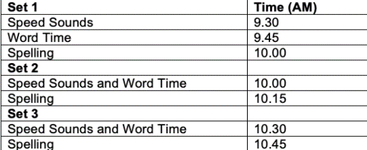
RWI - Practice spelling words containing the sound of the day from the RWI lesson (please ignore the dates for the set 2 and set 3 sounds. They are being repeated now as all of them have been covered). https://www.youtube.com/channel/UCo7fbLgY2oA_cFCIg9GdxtQ/featured
Ensuring your child is secure in all these sounds is vital to developing their reading skills so please continue to practice these daily or use the sounds provided in their original packs.

Maths games - https://www.topmarks.co.uk/ordering-and-sequencing/shape-patternshttps://www.topmarks.co.uk/learning-to-count/teddy-numbershttps://www.topmarks.co.uk/learning-to-count/helicopter-rescue I know we have used some of these before but always a good independent activity with a variety of different levels. Please keep counting and using numbers to 20.
Ways to stay active - https://www.bbc.co.uk/teach/supermovers
Going for a walk, riding your bike, playing chase games, making a hopscotch, throwing and catching games.

