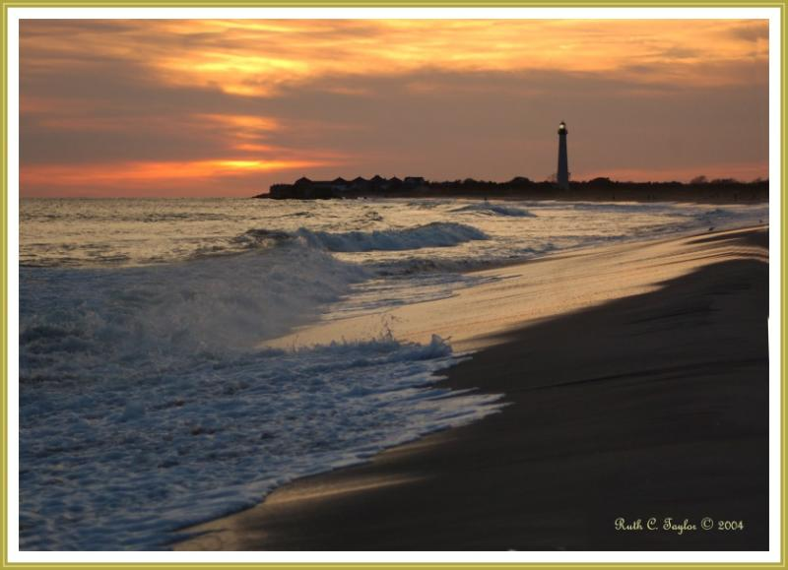

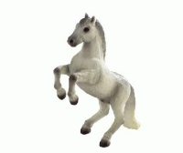
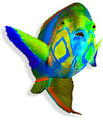

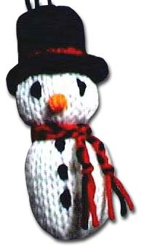
The Magic Box
I will put in the box
the swish of a silk sari on a summer night,
fire from the nostrils of a Chinese dragon,
the tip of a tongue touching a tooth.
I will put in the box
a snowman with a rumbling belly
a sip of the bluest water from Lake Lucerene,
a leaping spark from an electric fish.
I will put into the box
three violet wishes spoken in Gujarati,
the last joke of an ancient uncle,
and the first smile of a baby.
I will put into the box
a fifth season and a black sun,
a cowboy on a broomstick
and a witch on a white horse.
My box is fashioned from ice and gold and steel,
with stars on the lid and secrets in the corners.
Its hinges are the toe joints of dinosaurs.
I shall surf in my box
on the great high-rolling breakers of the wild Atlantic,
then wash ashore on a yellow beach
the colour of the sun. by Kit Wright

