Year 4 – Week 3, beginning 20/04/20

Children can complete their work in their home learning books.
Subject | Work at home ideas
Reading | - Reading Plus: Complete all readings allocated by Sunday.  - Read your own reading book.4 x a week. - Discuss the story and characters. Find three words that you don’t understand and look them up in a dictionary.  - Remember ALL reading is important! Read any books you have at home, share with your family. Perhaps you could read to brothers and sisters too.  - Reading comprehension (Hanzel and Gretel). Children should answer in full sentences. There are three variations of the story 1 star is the more basic with 3 being the most difficult. Only one version should be completed.
Spelling | - Revise year 3 and 4 common exception words. Have a test on 10 words of your choice. Any which are incorrect continue to learn. You can then choose some more words. We have included a spelling practice menu; you can choose form to help learn the words.
English | - SPAG-Word families.  - Re-read the story of Hanzel and Gretel, though this time concentrate on a part of the story e.g. When they are first left in the woods or when they see the house made of sweets etc. Take that section of the story and write at least two paragraphs explaining the senses of the character in detail.  - When you have completed your story. Read back through- reading the exact words you have written down. Edit your work. Make sure you are correcting punctuation and upscaling your vocabulary by using a thesaurus. There is an online thesaurus that can be used https://www.thesaurus.com/
Maths | Visit the following website:  https://whiterosemaths.com/homelearning/year-4/  Select ‘Week 1’.  Here you will find a selection of video clips about fractions/decimals. Please work through one video and the relevant activity each day – these need to be completed in the correct order. The activities and answers are provided on the same webpage.  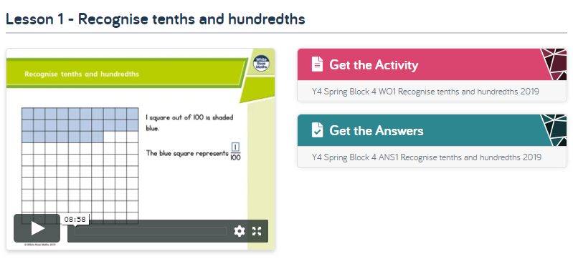  Here is an overview of the week:  Lesson 1 – Recognise tenths and hundredths.  Lesson 2 – Tenths as decimals.  Lesson 3 – Tenths on a place value grid.  Lesson 4 – Tenths on a number line.  Lesson 5 – Dividing 1 digit by 10.  Once you have completed the activity, you should then carry out some of the revision activities. Remember, you should be spending an hour each day on maths.  Revision:  - Times Table Rock Star 4 x a week or more.  - If you have finished the above from last week’s learning, then a further booklet has been added containing questions on the four operations e.g. add/subtract/multiply/divide.  - Math’s prodigy game.
Science | This week the children are to research melting points. The worksheets provided have all the information necessary to complete all tables and bar graphs. Remember that you have to put the metals in order of melting point and that when completing the bar graph, it will be easier if all amounts are rounded.
Topic | Write a story about discovering a tomb. Remember that you should plan this first. You should consider the time, setting e.g. where? Opening/beginning, middle and ending. Use your senses to help describe to the reader what can be seen, heard, smelt etc.
PE | Scavenger Hunt- Children will have to find items from a list either from rooms inside the house or the garden outside. You could variate this activity by turning it into a Treasure Hunt with clever clues to lead them to the next clue.
Art/  DT | Design your very own witches house from the Hanzel and Gretel story. If you could start by sketching your idea first and recording this that would be fantastic.
Computing | - Online safety activities.  - Scratch.
Music | The website below offers children the opportunity to explore different facets of music by watching different videos. Click on Essentials and watch as many as you would like.  https://www.bbc.co.uk/bitesize/subjects/zwxhfg8
French | Children will be given the opportunity to learn the days of the week in French.
RE | Children will design their own pop up Ester cards. They can use either the template which has been given to you or design their own.
PSHE | Write explanations for questions written on the PowerPoint for Feeling Good, which looks at different emotions and feelings.

