Improving the Environment
Year Four Homework Grid
Autumn Term one 2019

Please choose 4 activities from the grid and do one of these activities each week. You can use the resources in your homework folder to complete these activities and use it to store your work.
To be handed in on Monday 14th October.
Remember the expectation is that you read at least 4-5 times a week for 20 minutes, use Times Table Rock Stars, Reading plus and learn your spellings.
Maths  Practice your times tables. Which ones do you need to learn?  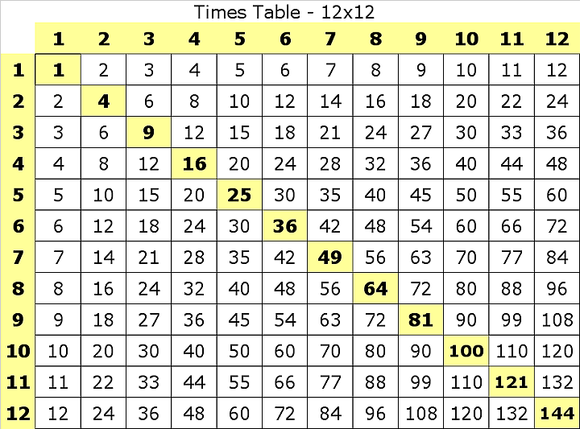 | Geography  Go for a walk in places such as the beach, park etc, What do you notice? What does that place need more of, e.g bins, benches, play-areas. Present your findings in your style, such as with photos and explanations, a table, a report. | English  Look through the year 3 spellings and find 10 words you do not know yet and practice them. Put them in a sentence to help learn them.  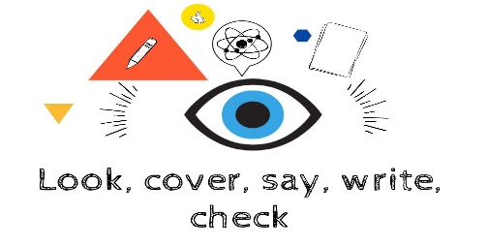
Maths  Use a dice to create two 3 digit numbers. Then add them together. Can you subtract them? Remember the largest number goes on top. | RE  Make a comic strip of the Christianity creation story. What happened on each of the 7 days?  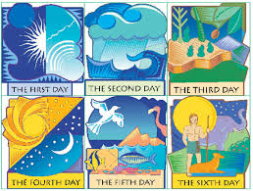 | Science  Create a fact file on the animal of your choice. Where does it live? What does it eat? Is it nocturnal?
Art  Draw a picture of someone moving- running, jumping, walking, swimming etc.  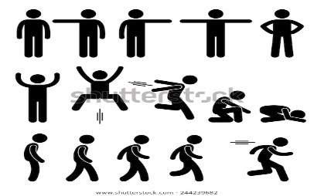 | English  Thinking about our book Gregory Cool, write a recount of some where you have travelled to. Where did you go? How did you feel? What was it like? | History  Find out some interesting facts about New Romney and what it was like in the past. 