This term, Beech and Birch class are continuing to learn about Egyptians.
Compulsory Weekly Homework
Each week you need to complete the activities below.
Reading Plus  Ensure all your weekly activities are completed. |  | Home Reading – (Daily)  Please record in your log |  | Times Table Rockstars  10 minutes (Garage and Studio) x 3  Spellings  Practice yr3/4 orange words
Optional homework
Over this half-term complete at least two of the homework activities below. The two pieces must be from different subjects.
Think carefully about which ones you want to do and remember to create a really good quality piece of work to share with the rest of the class!
Your work should be brought in during the week beginning 22/04/18.
ART | Make a 3D model pyramid.  Pinterest has some great ideas. |  | Find out about Egyptian art. What facts can you find?
Literacy | Write a poem about one of the characters in ‘Charlotte’s Web’ |  | Extend the story of Little Red Riding Hood and write a different ending.
Science | Create a word search using the vocabulary below;  incisor canine molar  oesophagus stomach  small intestine  large intestine  producers prey predators  Please ask for square paper if it is needed. |  | Using the link below follow the instructions for an experiment which shows how the digestive system works.  https://www.stem.org.uk/resources/elibrary/resource/35396/digestive-system-experiment  Record the process with photographs or pictures and an explanation for each stage.
Maths | 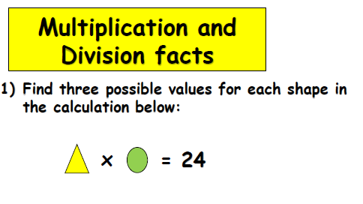 |  | 