Year 2 – home learning
Continue to complete weekly tasks of reading, practising red word spellings when they come home and times tables 2, 5, 10 and 3s.
Also please choose 2 grids to complete before half term. Practical tasks can be recorded in a number of ways, for example… brought in and shared, photographed, or describe in words etc.
Times Table Rock Stars  Mathletics | 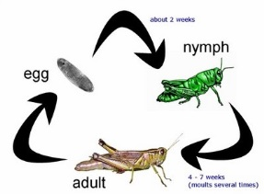  In Science we are learning about life cycles. Create your own life cycle of an insect or animal. This could be drawn, painted or you could use collage materials. |  | 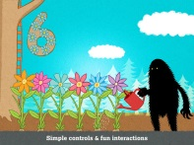  English – Our new book is The Lonely Beast. Write a letter to the lonely beast pretending to be another beast in another country. Tell him about where you live, what you do every day and how you are feeling.
Our RE unit this term is ‘Salvation’. We will be learning the Easter story. Make an information booklet explaining what Easter is, why its celebrated and why it is an important time for Christians. |  | 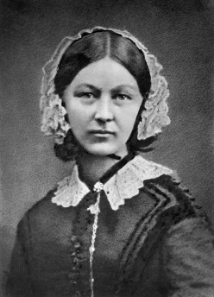  We are continuing to learn about Florence Nightingale in Topic this term. Can you produce a poster about Florence Nightingale to share with the class. | Practise 10 common exception words from the list at the front of the home learning book

