Year 2 – home learning
Continue to complete weekly tasks of reading, practising red word spellings when they come home and times tables 2, 5, 10 and 3s.
Also please choose 2 grids to complete before half term. Practical tasks can be recorded in a number of ways, for example… brought in and shared, photographed, or describe in words etc.
Times Table Rock Stars  Mathletics | Our Science topic is Materials.  Which material would be best to use to make a coat for St Nicholas Bear?  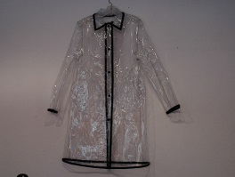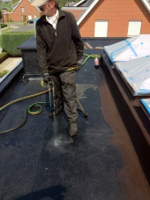 |  | 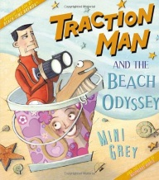  English – Our new book for this half term is Traction Man. Can you design your own suit for Traction Man
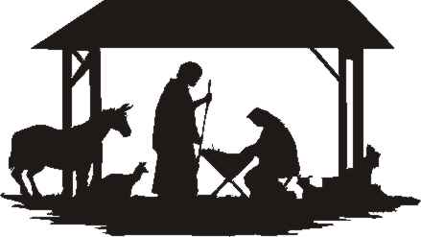  Our RE unit this term is ‘Incarnation’ which relates to the Nativity story. Create your own Nativity scene – this could be drawn, painted or it could be 3D |  | 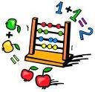  Addition and Subtraction  Create your own number bonds poster – this can be number  bonds to 10/20  /100  You can use both addition and subtraction – for example  7 + 3 = 10 so therefore 10 – 7 = 3 | Practise 10 common exception words from the list at the front of the home learning book

