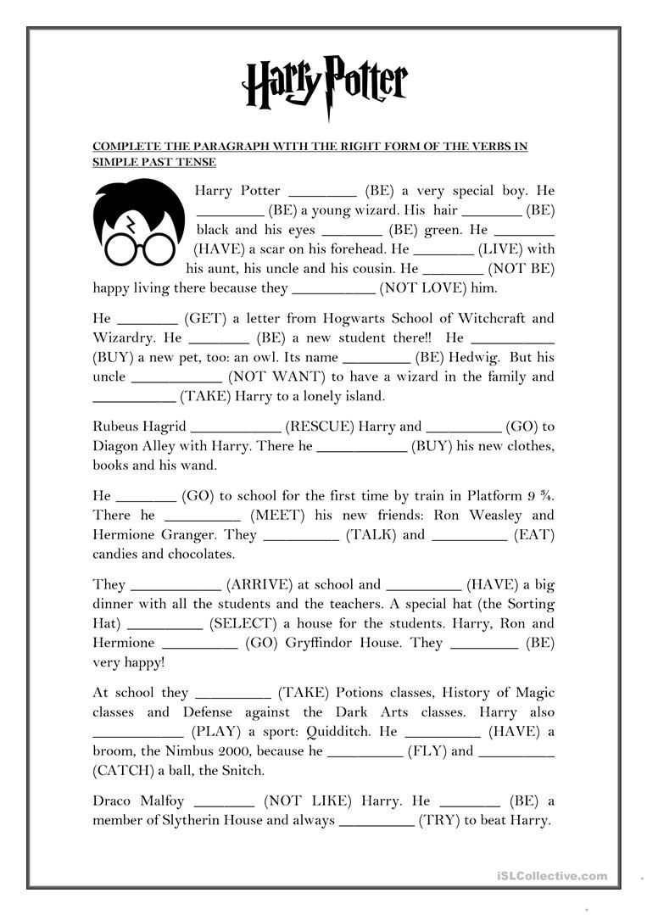

**Challenge:** Can you rewrite this in the Present Tense?