pie
proit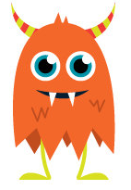
hair
yir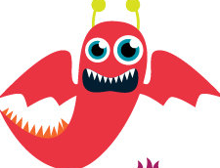
tue
bloig
blair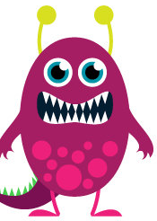
oam
tied

thoef
pede
gow
near
thigh 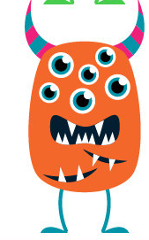
loak
zoyt
toyn
churd
murl
blirm
buen
urst
zawt
kawg
whike
whod
stoed
hear
Pete

Chead
haul
figh

