drawing
prine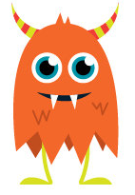
oc
yoo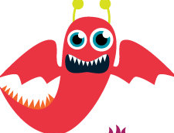
stime
blest
blat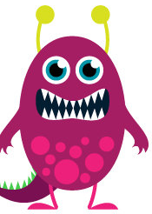
zam
jousting

thige
pride
pheed
tube
thix 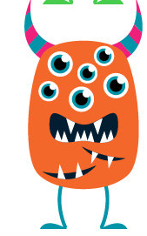
lesk
oct
tull
chald
mune
bline
hicke
ulst
zounb
kerg
wabe
cick
stoffe
spine
milkman

Chab
tone
forb

