sprin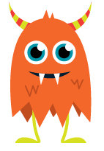
oc
koo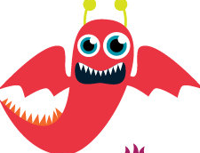
pim
blet
is
blat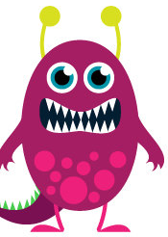
vam
an

shig
tide
photo
mum
thix 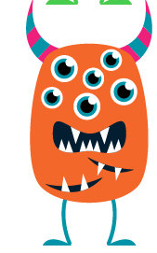
esk
uct
stoll
mald
queck
quim
hick
ulp
vount
werg
wape
snick
stroff
pig
pewter

Chab
cone
forb

