The Year Two Observer

Learning in Year 2 this week.

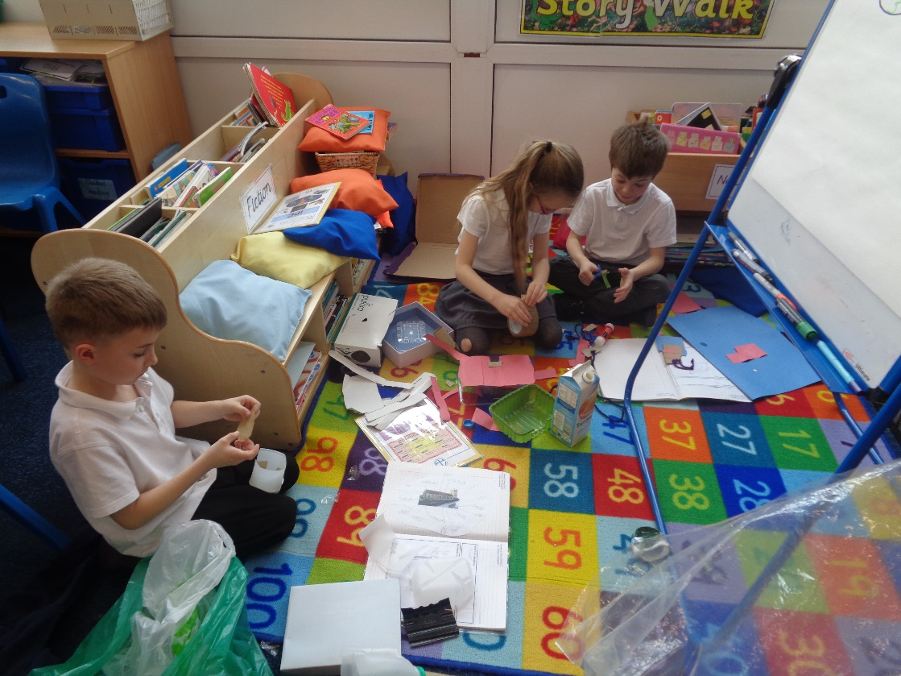
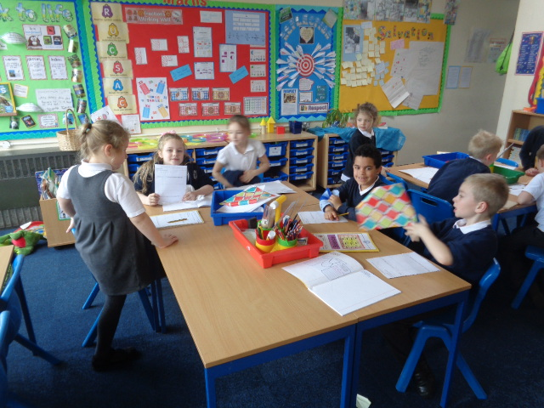
Maths

In Maths this week, we have been learning about equivalent fractions. We have also begun to count fractions and order them showing an understanding of the size. Some of us have been looking at place value and our understanding of tens and ones and how we can use this to help us add two numbers to=together.
General

In Year 2 this week, we have been extremely busy. In RE we have learnt about different symbols relating to the Easter story and what some of those symbols represent. This was presented in a collage using different coloured paper.

In Science, we have been learning about the properties of different materials. We tested a range of different materials to see what they could and couldn’t do.

In IPC, we have started creating our sculptures. We had our designs out in front of us to help us to follow. It wasn’t as easy as we thought it would be because some of the materials were difficult to cut and shape.

English

In English, we have created our own superhero story following the structure of the Traction Man story. We have tried to included words using the suffixes ing, ed, ful, ness and ment. We have also tried to include a range of punctuation including full stops, capital letters, question marks and exclamation marks.
Fox Class Sculpture Building!
Hare Class Experimenting!

