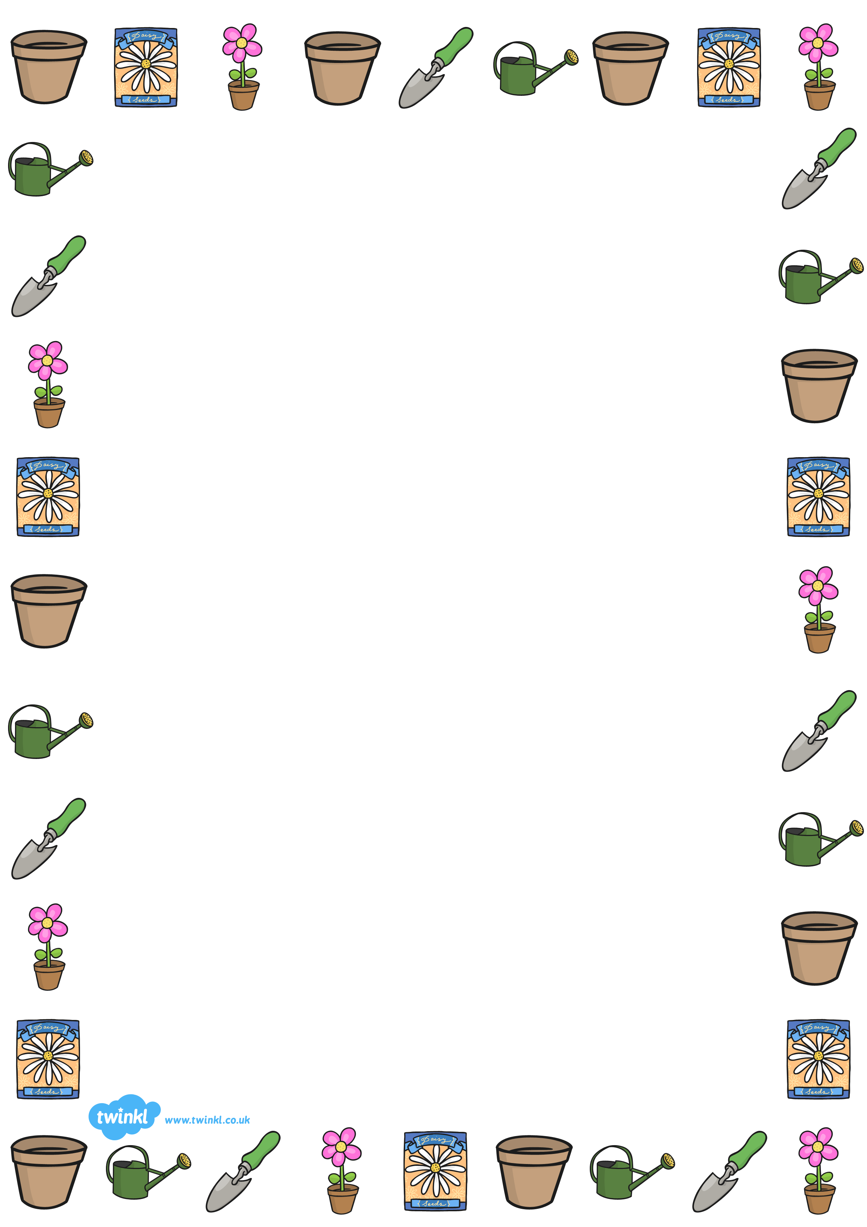

Dear Year One Parents,

Over the next 6 weeks those of us in Badgers and Otters will be following a unit of work on a theme that focuses on ‘Plants’ called Green Fingers.

In Science, we’ll be ﬁnding out:
• About plants that grow in our local area
• About the different parts of a plant
• What plants need in order to grow
• How to care for a plant

In Technology, we’ll be ﬁnding out:
• How to make a watering device

In Geography, we’ll be ﬁnding out:
• About plants that grow in other countries

The national curriculum expectations for Year One are to:
- Identify and name a variety of common wild and garden plants, including deciduous and evergreen trees
- Identify and describe the basic structure of a variety of common flowering plants, including trees
- Ask simple questions and recognising that they can be answered in different ways
- Observe closely, using simple equipment
- Performing simple tests
- Use their observations and ideas to suggest answers to questions
- Gather and recording data to help in answering questions.

All of the work we are going to do has been specially written to help your child reach the learning goals. Children will be reading, researching, writing, illustrating, working on their own and working in groups. We will be checking to see how well your child has learned through particular activities and asking children to explain their work, perhaps to you.

We already know the interest you take in your child’s work. If you can, please discuss with your child the work they have done as the term progresses and let them teach you.

Talk with your child about any plants you have at home and in your local parks and gardens. Point out the huge variety and beauty of the plants around you. Discuss how plants can grow from tiny seeds into huge trees.

By the end of the unit, we hope your child has achieved all of the learning targets. We hope they have had an enjoyable time in the classroom. And we hope you have enjoyed seeing your child work with enthusiasm. If you have any comments or questions about your child's learning, please get in touch.

Regards,
The Year One Team



GREEN FINGERS

