Dear Parents,

Our Term 1 IPC unit will be ‘Our World’. During this unit we will be focusing on Art, History, Technology, Science & Geography.

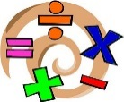
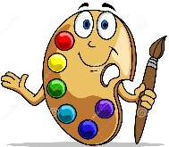
In Art we will be learning about different artists who capture environments.

In International we will be thinking about our town or country and creating our own fact files.

In History we will be finding out how New Romney has changed over the years.

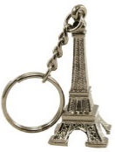
In Computing we will be creating our own news reports about animals.

In Geography we will be looking at maps of the local area. We will also be looking at different symbols used.

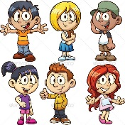
In Science we will be learning about plants and animals, including humans’. We will be looking at what an animal needs to survive in their habitat.

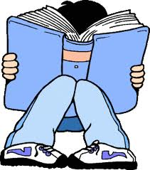
This term in English the children will be learning about characters and settings. The children will learn the features needed to write an engaging story. They will then use a storyboard or story map to plan and write their own stories. The children will also be learning about non-chronological reports and fact files.
Every week, the children will take part in Guided Reading, a range of different spelling activities and they will continue to learn their phonics.

In Maths the areas of learning are; counting, partitioning numbers, ordering numbers, place value and addition and subtraction.

For home learning, the children will have reading every day, Maths will be given out on Tuesday and returned by Monday. On occasions, the children will have some topic work.
In Year 2, we will have PE on a Thursday. Please ensure that their PE kits are in school every day.

We hope the children have an enjoyable start to the year and we hope you enjoy seeing your child learn with enthusiasm.

If you have any questions, please get in touch.

The Year 2 team.

Julie Lilly
Rebecca Reynolds

