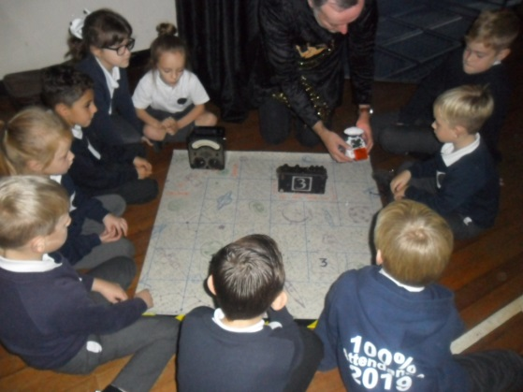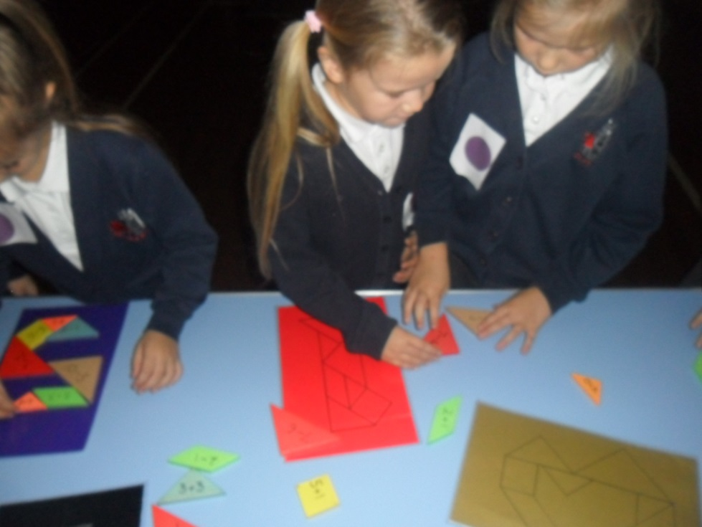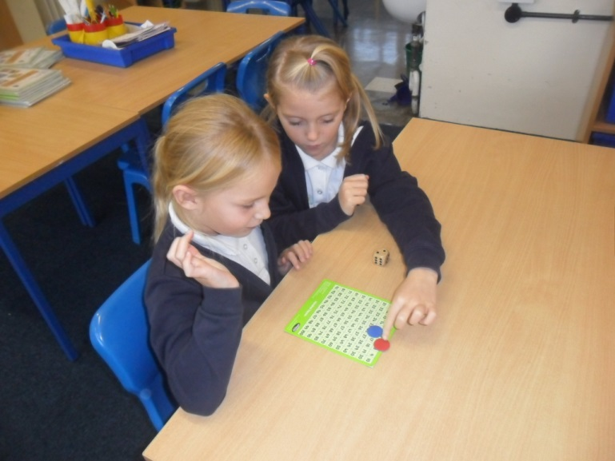 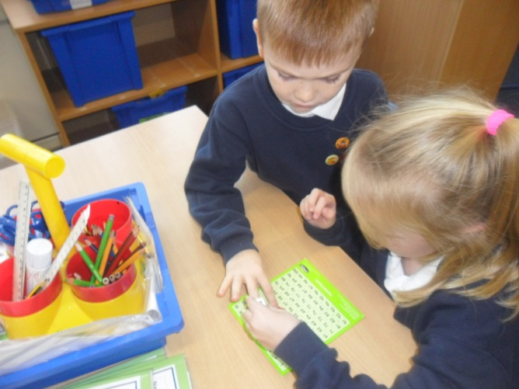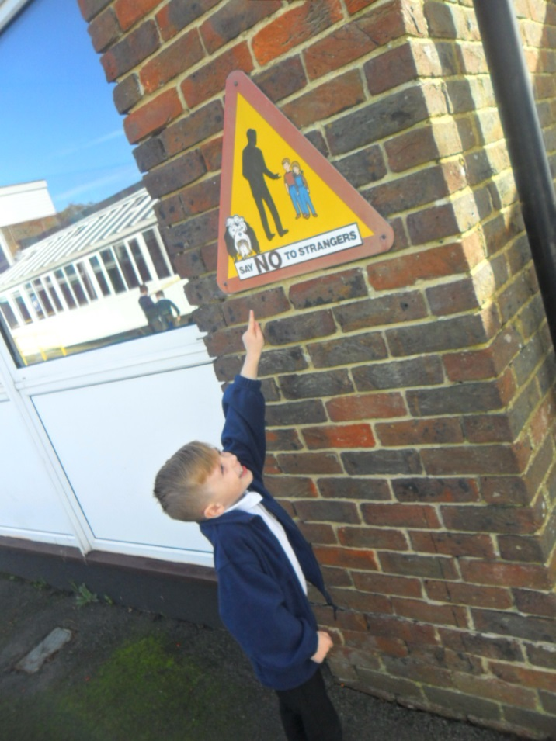 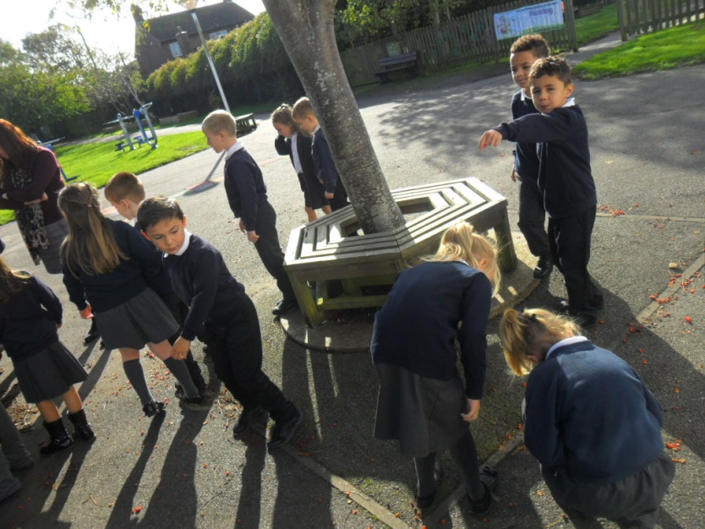

We had a super day on Tuesday when we were lucky enough to take part in many different maths workshops. We practiced our number bonds, 2D shape recognition, programming, odd and even numbers and addition and subtraction facts.

Maths Week in Year 2

We began with a shape walk around the school. This led in to a whole week of learning about 2D shapes.