Year 2 – home learning
Continue to complete weekly tasks of reading, practising red word spellings when they come home and times tables 2, 5, 10 and 3s.
Also please choose 2 grids to complete before half term. Practical tasks can be recorded in a number of ways, for example… brought in and shared, photographed, or describe in words etc.
Times Table Rock Stars  Mathletics | 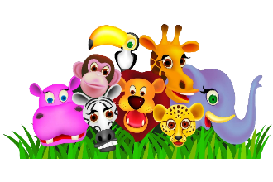  In Science we will be learning about Living things and their habitats. Could you make a habitat for an animal using materials from your recycling. |  | 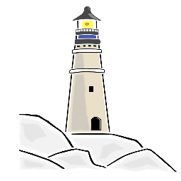  In English we will be looking at the story of The Lighthouse Keepers Lunch. Could you design and make your own lighthouse.
Our RE unit this term is Islam. Could you make a fact file showing what you have learnt about Islam this term. |  | Our Topic this term is ‘Hooray! We’re Going on Holiday’. Could you design and write a postcard with a drawing of your favourite beach and a message to tell us what you have been up to there. | Practise 10 common exception words from the list at the front of the home learning book

