Year 2 – home learning
Continue to complete weekly tasks of reading, practising red word spellings when they come home and times tables 2, 5, 10 and 3s.
Also please choose 2 grids to complete before half term. Practical tasks can be recorded in a number of ways, for example… brought in and shared, photographed, or describe in words etc.
Times Table Rock Stars  Mathletics | 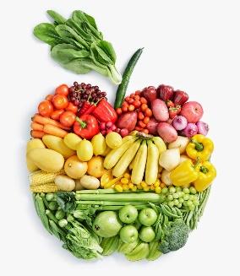  In Science we are learning about Animals including Humans. Keep a food diary to see what types of food you eat in a week. You can draw the food if you would like to. |  | 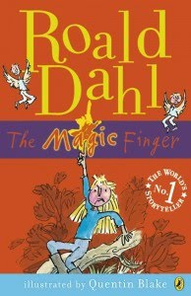  English – Our new book in Magic Finger. Can you write your own Magic Finger story?
Our RE unit this term is ‘Gospel’. We will be learning about the good news that Jesus brings. Draw or make a model showing one of the stories in the Bible that shows the ‘Good News’ that Jesus brings. |  | 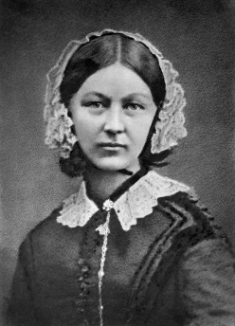  We will be learning about Florence Nightingale in Topic this term. Can you make a Fact File about Florence Nightingale and what makes her famous? | Practise 10 common exception words from the list at the front of the home learning book

