**Friday 21st April 2017**

**ISSUE: 2**

**The Year Six Scoop**

Welcome back! We hope you all had a restful Easter break. It has already been a busy start to the term. On Thursday, we were extremely lucky to have a visit from Lt Colonel Igor Pismenski, He was a Helicopter Pilot who flew 24 Missions over the Chernobyl Reactor to extinguish the fire. For his bravery, he was awarded a Red Cross. Our visitors commented on the brilliant behaviour of our Year 6s and were

very impressed with their Interesting

and mature questions. Well done!

Miss Barrow & Mrs Longman

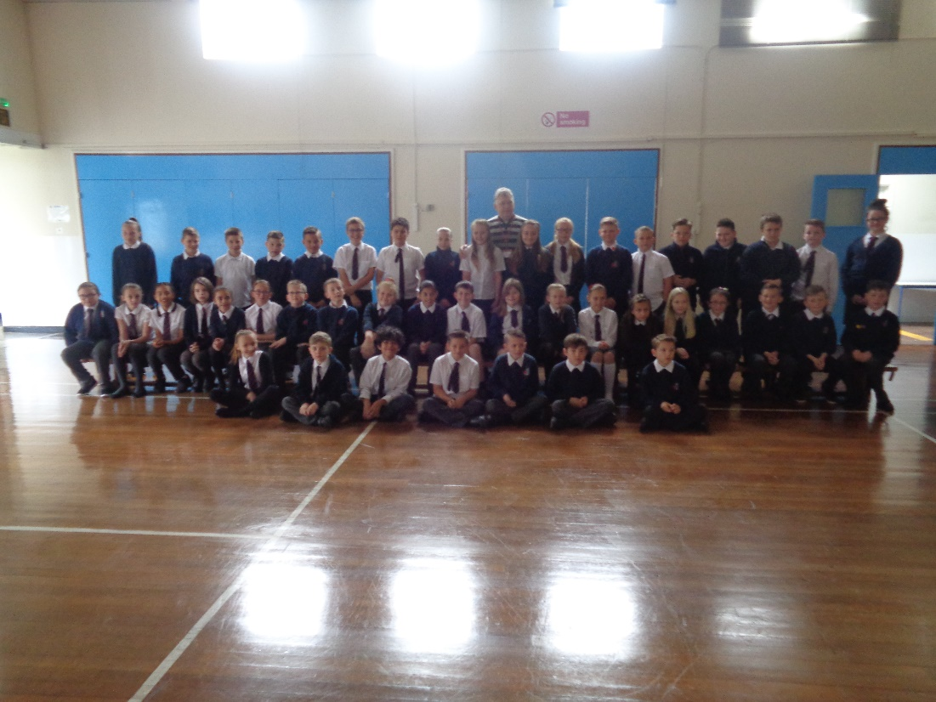

**Home Learning**

* Complete the SPAG test.
* Spend at least an hour on Mathletics.
* Please continue to read daily or log on to readtheory.org to work on your comprehension.

**Due in Wednesday 26th April**



A huge **Thank You** to everyone who donated cakes for this morning’s cake sale. It was a great success and we made £201.50 towards our trip.

[](http://www.bing.com/images/search?view=detailV2&ccid=uvpj94ek&id=84C95F728282762BD93B84881FE168463298EF35&thid=OIP.uvpj94ek9Vktzg8eAYheGAEsDr&q=SAVE+THE+DATE+clipart&simid=608053008463496746&selectedIndex=0) BINGO – Fri 12th May



**MOCK SATS**

Next week, over 3 days we will be completing mock SATS. This will prepare you for the real thing. As always, if you have any concerns or questions, please come and see one of your teachers.





**Don’t forget…**

*This week we have started the Summer Reading Challenge. Please make sure you read at least 5 times each week to be in with the chance to win a Fire for Kids Tablet.*