Badger and Otter Home Learning 28th April

This week we have been writing a news report about the enormous turnip, the children learnt how to explain who, when, where and what in their reports.

In maths we have been learning how to represent 2,5,10 times tables in arrays, the children have learnt how to count the number of objects in the first row and multiply it by the number of rows to find the answer.

Please continue practising the 100 key words in your homework folders and the 2,5,10 times tables, to achieve their bronze award they need to answer 30 questions in 10 mins, they’re all muddled up so need to know 5 x 5 = 25 without counting up to 25 in 5’s!

As you can see our outdoor area is developing each week, we try and fit in as much work as we can do develop it, and will be looking for some parent helpers in the future to help us with some larger things!

In the meantime we would like to challenge the children and adults to create a bughouse for our outdoor area. We are keen to invite as much wildlife into our garden, and the children’s birdhouses are already working well!

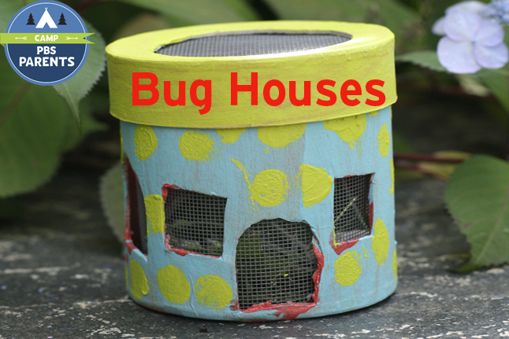
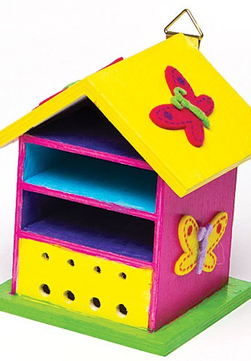
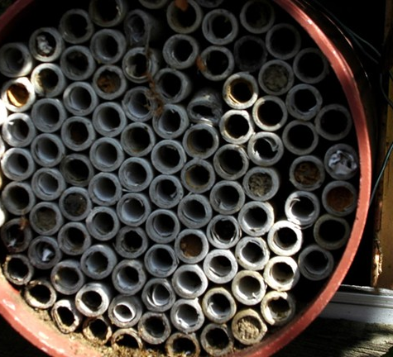
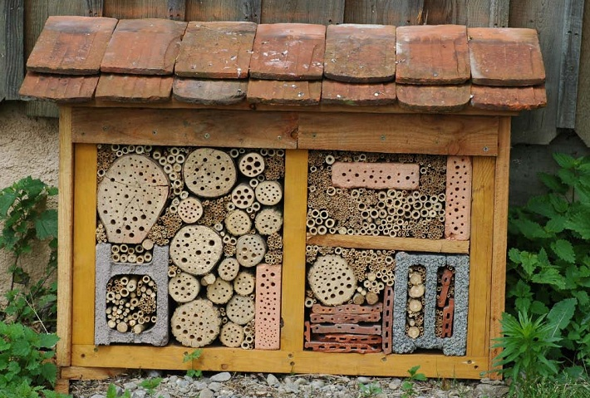
Your bug house needs to be safely made and able to stay outside in the rain.. here are some ideas!

If you haven’t got resources at home, we have some pallets at the back of our area which need filling so feel free to bring in things to make a cosy home for a variety of bugs!
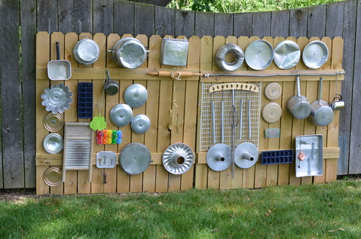
If you have any old baking tins, baking trays, muffin tins, sieves, measuring jugs (plastic) we are keen to make a music station for the children too! – Any donations are greatly welcome!

Thank you for keeping children away from our outdoor resources, please continue this, as it helps develop the trend throughout the school.

Have a great bank holiday weekend!
Miss Common and Mrs Humphries

