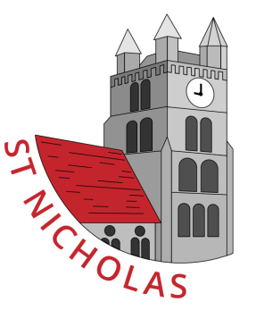
Tuesday 21st February

Dear Parents,
We are excited to tell you about our new topic ‘We are what we eat’ as part of our IPC curriculum.
This term the children will be learning how to stay fit and healthy, about the 5 senses and healthy eating. Over the next term we have many exciting events planned for our Year 1 pupils.
Some of these will involve tasting foods, for example on Friday this week we are lucky to have a visit from the Tesco Farm to Fork project. The children will be learning how food is produced and how it arrives in our supermarkets. During the session the children will be making their own fruit kebabs.
We ask you please to advise us of any allergies ASAP so that we can make alternative arrangements if necessary.
Thank you so much for your continued support.
Kind Regards
Year One Staff
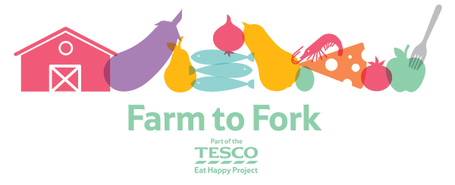

P.S Rugby Tots also starts for Year One on Thursday this week – please ensure that all PE kits have been returned by then!

