Home Learning – 21.10.16 (Due in 02.11.16)
Home Learning for half term:
In Science we have been learning about habitats and food chains.
Using a shoe box please create your own habitat thinking about where different animals live. Please use the examples below for inspiration.
Thanks for your continued support.
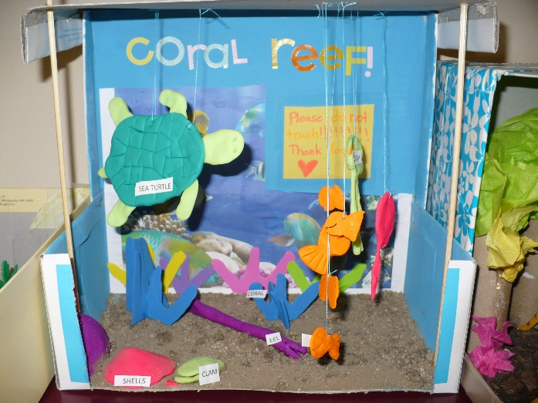
Year 4 Team.
