Homework - Beech and Rowan - 23.09.16 (Due: Weds 21st Sept)
- Learn the –ible and -able spellings for a test next Wednesday.
- To help you to learn your spellings complete page 32
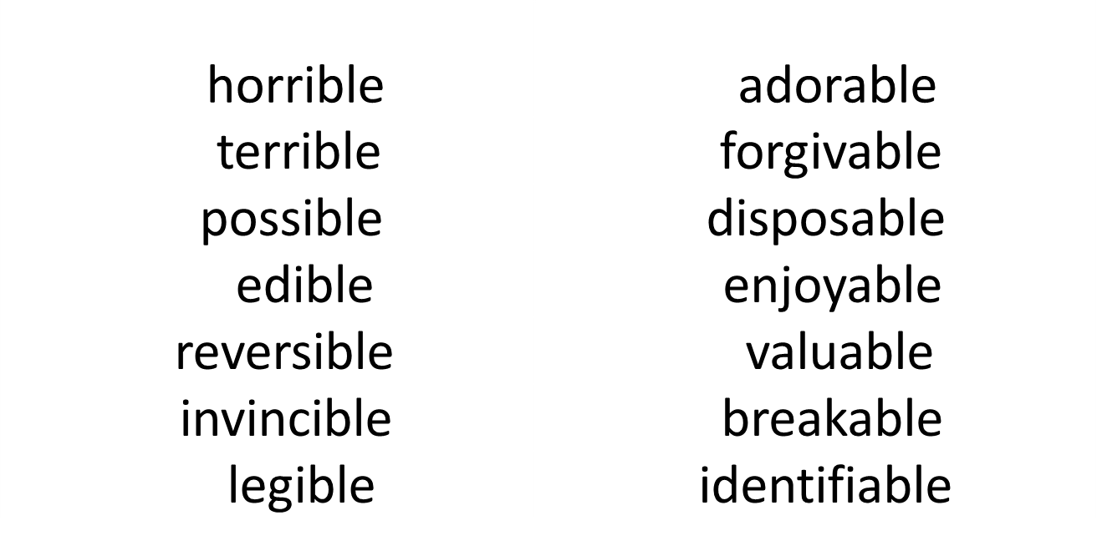

- Complete Task C on page 4 in the Mental Arithmetic Booklet.

- Please make sure you read at home at least 4 times this week. Remember to have an adult to sign at least once

- Practise your times tables- we test these weekly.

Homework - Beech and Rowan - 23.09.16 (Due: Weds 21st Sept)
- Learn the –ible and -able spellings for a test next Wednesday.
- To help you to learn your spellings complete page 32

- Complete Task C on page 4 in the Mental Arithmetic Booklet.

- Please make sure you read at home at least 4 times this week. Remember to have an adult to sign at least once

- Practise your times tables- we test these weekly.

